Integrated Training Manual | 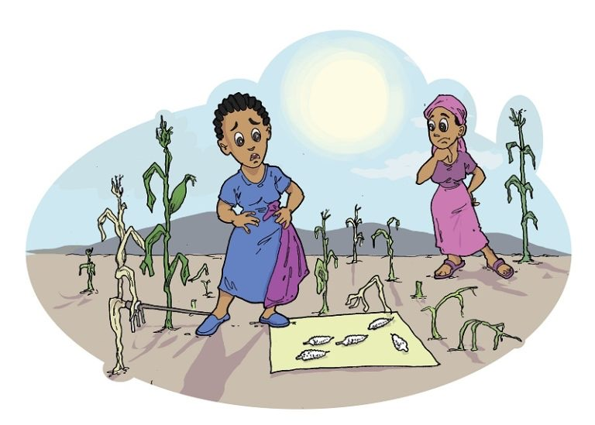
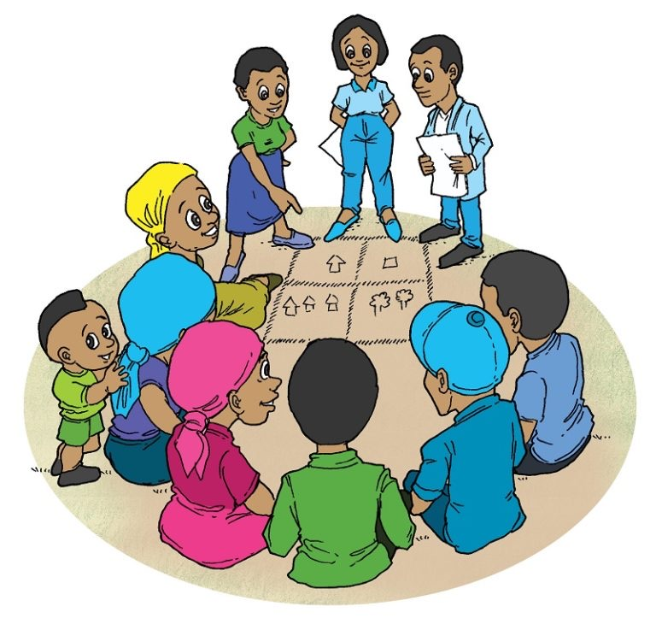
MINISTRY OF ENVIRONMENT
  - Mainstreaming Gender- Environment and Climate Change Nexus in Sectors’ Policy, Planning and Budgeting:
AGRICULTURE, ENERGY, INDUSTRY AND URBANIZATION
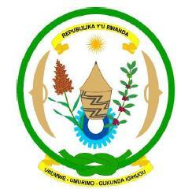
PEA for SDGs - Rwanda Environment Management Authority

November, 2019

Revisions record

Revision | Date | Originator | Checker | Approver | Description
0 | 18 October 2019 | Arlette Nyinawinkindi Iyakaremye | Mary Rucibigango  Theogene Twahirwa  Olive Mukandahiro | Janet Umugwaneza | Draft for discussion with PEA/REMA and stakeholders
1 | 11November 2019 | Arlette Nyinawinkindi Iyakaremye | Mary Rucibigango  Theogene Twahirwa  Olive Mukandahiro | Janet Umugwaneza | Draft for validation with PEA/REMA

This training manual has been produced in December 2019 by the Rwanda Environment and Management Authority through the Poverty and Environment Action (PEA) in partnership with the the United Nations Development Programme (UNDP)
This manual builds on several existing policies, reports and manuals on gender equality and gender mainstreaming in environment and climate change. A selective consolidation was adjusted to the needs of the Rwanda Environment and Management Authority. It has been particularly inspired by the following organisations and their tools for gender equality or for environment mainstreaming guidelines:
Rwanda Environment and Management Authority, Rwanda Ministry of Gender and Family Promotion, The Gender Monitoring Office, International Union for Conservation of Nature (IUCN) and the United Nations Development Programme (UNDP) and the UN Environment. 2016. Global Gender and Environment Outlook, ENERGIA International Network on Gender and Sustainable Energy, United Nations Educational, Scientific and Cultural Organization (UNESCO), Food and Agriculture Organization (FAO) and the Women’s Environment and Development Organization (WEDO) as part of the Global Gender and Climate Alliance (GGCA).

Main author:
Iyakaremye Nyinawinkindi Arlette
Revisions:

External contributions:
Experts and professionals from REMA, PEA Project and Rwanda Ministry of Environment, MIGEPROF and other Gender machinery in Rwanda.

Validation process: The following institutions participated in the validation process: REMA, PEA project,

English editions and formatting:
Elena Ortiz
Niyigena Francis

Images and info graphics:
Three mountains, learning advisors
Threemountains.academy

ACKNOWLEDGMENT

This training manual has been developed as part of the assignment to evaluate the status of gender-environment and climate change mainstreaming in relevant polies and strategies in high-priority sectors on behalf of the Poverty Environment Action in Rwanda Environment and Management Authority (REMA). The training manual has also benefited from the critical comments and inputs made by participants from high-priority sectors including the environment and climate change sub-sector. Ample credits go to the United Nations Development Programme for its financial support to the Poverty Environment Action for SDGs/REMA from which the training manual was developed. Finally, acknowledgements goes to all support and contributions from lead consultant for this assignment, the experts and institutions that directly and indirectly helped in the review or provided all the necessary information and data.

Acronyms
% | Percentage
BPfA | Beijing Platform for Action
CEDAW | binding Convention on the Elimination of All Forms of Discrimination against Women
CSOs | Civil Society Organizations
EICV | Enquête Intégrale sur les Conditions de Vie (Integrated Household Living Conditions Survey)
E&CC | Environment and Climate Change
ENR | Environment and Natural Resources
FONERWA | Rwanda National Climate and Environment Fund
GBS | Gender Budget Statement
GBV | Gender Based Violence
GMO | Gender Monitoring Office
HH | Household
MIGEPROF | Ministry of Gender and Family Promotion
MININFRA | Ministry of Infrastructure
MoE | Ministry of Environment
NST1 | National Strategy for Transformation 1
PEA | Poverty- Environment Actions
REG | Rwanda Energy Group
SDGs | Sustainable Development Goals
SEZ | Special Economic Zone
SSP | Sector Strategic Plan
ToT | Training of Trainers
IWRM | Integrated Water Resources Management
ICS | Improved cooking stoves
DDS | District development strategies
ESIA | Environmental social impact assessment
NDCs | Nationally Determined Contributors
SEZ | Special economic zones
FMF | Female managed farms
FHH/MHH | Female headed household/Male headed household
IPM | Integrated Pest Management
PoA | Programs of Actions
CBD | Convention on Biodiversity
BRS | Breton, Rotterdam and Stockholm convention
GHG | Green House Gases
GSF | Gender Statistical framework

Contents

Revisions record 1
Acknowledgment 3
Acronyms 4
Glossary of key concepts 8
Module 1: Course introduction and Organization 10
Module 2: Gender-Environment & Climate change nexus 12
Lesson 1: Defining key gender concepts 14
Lesson 2: Key concepts in Climate change 17
Lesson 3: Environment and Climate Change policy frameworks 18
Lesson 4: The seven steps of Gender Mainstreaming 20
Module 3: Building a foundation for Gender Analysis 24
Lesson 1: What is gender analysis? 25
Lesson 2: Gender Analysis Toolkit 27
Practical exercise 31
Module4: Critical Areas for mainstreaming Gender, Environment and Climate Change 32
Lesson 1: Gender mainstreaming in Sustainable, Diversified Intensification of Agriculture 33
Gender situation analysis 33
Entry points for gender mainstreaming along in policy or planning cycle - 35
Case study: gender mainstreaming in sustainable land management 36
Lesson 2: Gender Mainstreaming in Integrated Water Resources Management 37
Gender situation analysis: Who does what? 37
Case study: Assessing the gender-related impacts of water supply interventions in north-west India
Lesson 3: Gender and Energy efficiency 41
Gender situation analysis 41
Entry points for gender mainstreaming 42
CASE STUDY: Women solar engineers trained by the Barefoot College 43
Lesson 4: Gender and Pollution Management in Low carbon Urban Systems 44
Gender issues in law carbon urban system 44
Entry points for gender mainstreaming 45
Women based organization improve livelihoods from waste management and recycling 46
CASE STUDY: Rwanda’s Climate smart villages 46
Lesson 5: Gender sensitive approaches for Sustainable forestry, agroforestry and biomass Management
Gender issues in sustainable forestry, agroforestry and biomass 47
Sample Gender Sensitive Indicators 48
Case study: Improving women opportunities in forest resources Burkina Faso 49
Lesson 6: Gender Mainstreaming in Climate Change 51
Gender issues in climate change 51
Case study: Lack of gender response in early warning 54
Lesson 7: Gender, green industry, wastes and Chemical Management 56
Entry points for gender mainstreaming 57
Module 5: How to Translate Policies Into Concrete Projects? PRACTICAL SESSION 58
Practical exercise 59
Module 6: Gender Responsive Planning and Budgeting 60
What is gender responsive planning/programming? 61
What is gender-responsive budgeting (GRB) ? 63
What is a gender budget statement? 63
Practical session: 64
Gender Mainstreaming in useful tools for environment and climate change 65
References 66

Glossary of key concepts
Gender mainstreaming entails identifying and addressing gender issues in all development projects and programmes, irrespective of the sector or type of project, and at all stages of development - from planning and implementation to monitoring and evaluation.
Gender Gap/issue: Any disparity and inequality between women’s and men’s condition due to their position or role in society. It concerns inequalities in terms of their participation, their access to opportunities, rights, power to influence and make decisions, incomes and benefits, and control and use of resources. (Source: GEF Policy on Gender Equality 2017)
Gender sensitivity: is the ability to recognise gender issues - particularly women's different perceptions and interests arising from their locations and gender roles. If development programmes do not take gender issues into account, they become gender insensitive or gender blind in as much as they fail to recognise the different needs of either women or men. If, on the other hand, a programme takes gender issues into account, it becomes gender responsive.
Gender-sensitive indicators: An indicator is a pointer, a measurement, number, fact, opinion and or a perception that directs attention to a specific condition or situation. It measures changes in that condition over time by providing a close look at the results of initiatives and actions. Using an indicator involves comparison with the norm.
Ecosystem: This is a functional unit consisting of living organisms, their non-living environment and the interactions within and between them (IPCC, 2014).
Ecosystem services: Ecological processes or functions having monetary or non-monetary value to individuals or society at large. These are frequently classified as (i) supporting services such as productivity or biodiversity maintenance, (ii) provisioning services such as food, fibre or fish, (iii) regulating services such as climate regulation or carbon sequestration and (iv) cultural services such as tourism or spiritual and aesthetic appreciation (IPCC, 2014).
Emissions: The release of greenhouse gases and/or their precursors into the atmosphere over a specified area and period of time (UNFCCC, 1992).
Green growth: means fostering economic growth and development, while ensuring that natural assets continue to provide the resources and environmental services on which our well-being relies (OECD)
Environmental Impact Assessment: A systematic examination conducted to determine whether a programme, activity or project will have any adverse impacts on the environment.
Greenhouse gases: Gaseous constituents of the atmosphere, both natural and anthropogenic, that absorb and re-emit infrared radiation (UNFCCC, 1992).
Payment for Environmental Services (PES): A market-based approach to conservation based on the twin principles that those who benefit from environmental services (such as users of clean water) should pay for them and those who generate these services should be compensated for providing them.
Gender Equity is the process of being fair to men and women. To ensure fairness, measures must often be put in place to compensate for the historical and social disadvantages that prevent women and men from operating on a level playing field. Equity is a means. Equality is the result.
Gender relations are those established between women and men, based on the manner in which a certain culture and society understands the meaning of being a woman or a man. These relations affect all scopes of daily life.
Gender Balance: The equal and active participation of women and men in all areas of decision-making, and in access to and control over resources and services. (FAO Term Portal)
Early warning system: The set of capacities needed to generate and disseminate timely and meaningful warning information to enable individuals, communities and organisations threatened by a hazard to prepare to act promptly and appropriately to reduce the possibility of harm or loss (IPCC, 2014).
Mitigation: This refers to efforts to limit or absorb gas emissions which contribute to climate change. Emissions can be limited by moving away from dirty fossil fuels (i.e. wind power) or by being more efficient when using energy (reducing consumption). Greenhouse gases can also be removed from the atmosphere by plants (called carbon sequestration). One way of managing the deployment of mitigation activities is through an international carbon market (GoR, 2011).
Gender bias: Making decisions based on gender that result in favouring one gender over the other which often results in contexts that are favouring men and/or boys over women and/or girls.
Gender blindness: The failure to recognize that the roles and responsibilities of men/boys and women/girls are given to them in specific social, cultural, economic and political contexts and backgrounds. Projects, programmes, policies and attitudes which are gender blind do not take into account these different roles and diverse needs, maintain status quo, and will not help transform the unequal structure of gender relations
Gender equality programming: An umbrella term encompassing all strategies to achieve gender equality. Important examples include gender mainstreaming, gender analysis, prevention and response to gender-based violence and sexual exploitation and abuse, promotion and protection of human rights, empowerment of women and girls and gender balance in the workplace.
Gender indicators: Criteria used to assess gender-related change in a condition and to measure progress over time toward gender equality. Indicators used can be quantitative (data, facts, numbers) and qualitative (opinions, feelings, perceptions, experiences).
Gender mainstreaming / integrating: A strategy to accelerate progress on women’s and girls’ rights and equality in relation to men and boys. This is the chosen approach of the United Nations system and international community toward implementation of women’s and girls’ rights, as a sub-set of human rights to which the United Nations dedicates itself. Gender equality is the goal. Gender mainstreaming is the process of assessing the implications for girls and boys and men and women of any planned action, including legislation, policies and programmes. It is a strategy for making girls’ and women’s, as well as boy’s and men’s, concerns and experiences an integral dimension of the design, implementation, monitoring and evaluation of policies and programmes so that girls and boys and women and men benefit equality, and inequality is not perpetuated.
Sex disaggregated data{Data that is cross-classified by sex, presenting information separately for men and women, boys and girls. When data is not disaggregated by sex, it is more difficult to identify real and potential inequalities. Sex-disaggregated data is necessary for effective gender analysis

Module 1: Course introduction and Organization

About this manual
This training manual has been developed to enhance the knowledge and gender mainstreaming skills in in policy cycle, including gender analysis and the integration of gender –environment nexus into the design, planning and budgeting of high- priority sectors interventions for environment and climate change. This manual is particularly relevant for environment and natural resources-related interventions and practices that seek to promote participation and reduce the inequality that exists between natural resources-dependent women and men, especially among the poor or marginalized people living in rural areas.
This training manual also aims to help trainers facilitate a learning process that focuses on the development of knowledge and skills to mainstream gender-environment into other strategies and policies interventions. In the long-term, REMA expects the manual to help achieve gender equality and equity in the environment and natural resources, and expect it to contribute substantively to two important principles of the National Environment and Climate change policy and Rwanda Green Growth and Climate Resilience Strategy, namely gender equality and equity and inclusiveness. To be achieved through:
- Ensuring that the identification and analyses of problems and the formulation of policy options are informed by gender considerations.
- Women participate equally with men as decision-makers in rural institutions and in and in local community governance committees in shaping and implementing relevant laws, policies and programmes.
- Women and men and the youth have equal access to and control of decent off-farm employment and income, land and other productive resources, specifically in the agriculture, industry, energy and urbanization sector.
- The manual was also designed based on two important strategic pillars in the ENR gender mainstreaming strategy (MoE, 2019) and PEA for SDGs project.
- Holistically, address the gender –poverty and environmental challenges and mainstreaming in development policy framework for equitable access and benefits over.
- Seek opportunities to narrow gender gaps in environment and natural resources management.
The aim of this manual is to provide trainers, gender experts and other professionals tasked with capacity building or gender mainstreaming in their respective organisations with a step-by-step guide and instructions on how to present complex topics linked to gender equality-environment nexus in an understandable, easy to follow and participatory manner. The manual is conceptually organized in six different modules and covers following topics:
- Module 1: Course introduction and organization
- Module 2: Gender, environment and climate change nexus
- Module 3: Building a foundation for gender analysis
- Module 4: Critical areas for mainstreaming Gender E&CC
- Module 5: How to translate policies into projects? Practical session
- Module 6: Gender responsive planning and budgeting

This manual builds on several existing reports and manuals on gender equality and gender mainstreaming in environment, combining them, and adjusting to the needs of the Rwanda Environment and Management Authority. It has been particularly inspired by the following organisations and their tools for gender equality or for environment mainstreaming guidelines:
The Rwanda Environment and Management Authority, The Rwanda Ministry of Gender and Family Promotion, The Gender Monitoring Office, International Union for Conservation of Nature (IUCN) and the United Nations Development Programme (UNDP) and the UN Environment. 2016. Global Gender and Environment Outlook, ENERGIA International Network on Gender and Sustainable Energy, United Nations Educational, Scientific and Cultural Organization (UNESCO), Food and Agriculture Organization (FAO) and the Women’s Environment and Development Organization (WEDO) as part of the Global Gender and Climate Alliance (GGCA).

This training manual users
The primary target audiences for this manual are trainers or professionals who work in designing and implementing environment-related learning interventions. The manual is also relevant for government officials and development workers who want to assess gender issues in relation to environment and natural resource organizational management. As such, this manual is also useful for gender focal points or experts working for public institutions and government authorities.
The training module aims at supporting the trainees to better understand, design, organizing, conduct and follow up on gender equality and gender mainstreaming training. The training can be adopted to cater for various audiences, including representatives of national and local government institutions, civil society organizations, inter-government organizations, media organizations, etc.
The development team of this training manual recommends that a training team with a variety of skill sets be assembled to conduct the training proposed here. Most importantly, basic understanding of gender concepts and willingness of the training team to conduct a self-reflection of their own personal gender values. Ideally, at least one member of the training team should be familiar with gender concepts and social or cultural norms that might hinder the learning process and perpetuate gender stereotypes.
About this training
On the first day of the course, after general introduction of participants, a briefing on the training objectives and organization and structure will be presented. The course content will kick- off with Module 2 and 3: introduction to key gender concepts and principles. Gender analysis methodology will also be taught. These will be discussed in relation with environment and climate change issues for Rwanda. For the second module (module 2) specific international commitments will be continuously integrated in respect of the environment & CC and gender action planning.
The second and third days will cover module 3 with its seven session to entails gender, environment and climate change lecture, the analysis of related gender based constraints and strategies to address them at national context. The day will include theoretical and practical exercises, plenary discussions as well as case study presentation. Including tutorials involving group presentations and Q&A. A daily wrap-up session at the end helps participants to capture take-away messages from lecture and discussions. The fifth day would be used for practical exercise or feedback presentation from groups as requires more time.

Module 2: Gender-Environment & Climate change nexus
Introduction

This module introduces the gender and environment & climate change nexus, including an overview of the key definitions in gender, environment and climate change. The key linkages that form this nexus, how should gender be mainstreamed in environment and climate change for Rwanda context. The module illustrates the links between gender, environment and climate change across a range of thematic areas, translated here as priority programs of actions. This module kicks-off the seven step of gender mainstreaming after defining the approach.

Learning outcomes:
After completing the module, participants will be able to:
- Understand the objectives of the training
- Understand the key concepts in gender and environment;
- Understand the policy framework for gender, E&CC mainstreaming
- Understand how gender mainstreaming in policy cycle is implemented;
- Step-by-step toolkit for gender mainstreaming in specific program/project cycle
- Every participant goes back in reflexion of gender and sex and Gender roles in personal life (home, work, field work
Activities:
- The course consists of:
- plenary lecture session;
- literature study and review (hands out);
- Quiz
- group work and feedback presentations;

QUIZ:
What is the difference between gender and Sex?

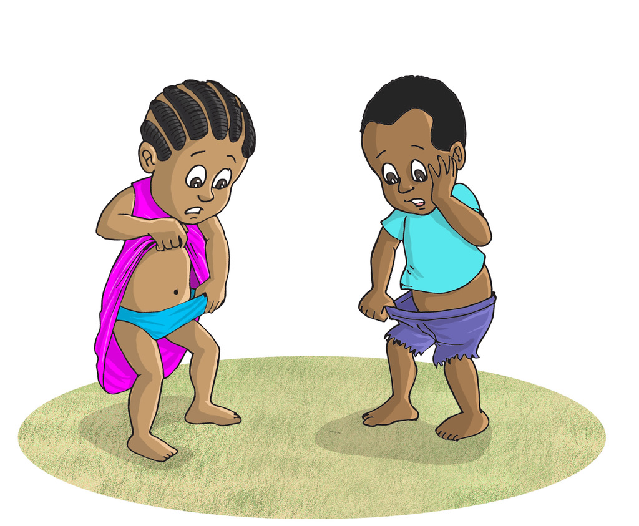

What is gender identity?
Is gender about women and girls?

Lesson 1: Defining key gender concepts
What is gender?

The term “gender” refers to socially ascribed roles, responsibilities and opportunities associated with women and men, as well as the hidden power structures that govern relationships between them. Gender is “... in essence, a term used to emphasize that sex inequality is not caused by the anatomic and physiological differences that characterize men and women, but rather by the unequal and inequitable treatment socially accorded to them. In this sense, gender alludes to the cultural, social, economic and political conditions that are the basis of certain standards, values and behavioural patterns related to genders and their relationship” (Riquer, 1993).

Gender and gender roles
- People are born female or male, both learn to be girls and boys who grow up into men and women.
- They are taught what the appropriate behaviors and attitudes, roles and activities are for them, and how they should relate to other people.
- This learned behaviour is what makes up gender identity and determines gender roles.
Gender as a process
- As a process gender creates the social differences that define “woman” and “man”.
- In social interaction throughout their lives individuals learn what is expected, see what is expected act and react in expected ways: To be a good mother, to be a heterosexually desired object…
- Everyday gendered interactions build gender into family, the work process and other organizations and institutions, which in turn reinforce gender expectations for individuals.
Gender equality
Gender is the concept that all human beings, both men and women, are free to develop their personal abilities and make choices without the limitations set by stereotypes, rigid gender roles, or prejudices. Gender equality means that the different behaviours, aspirations and needs of women and men are considered, valued and favoured equally. It does not mean that women and men have to become the same, but that their rights, responsibilities and opportunities will not depend on whether they are born male or female.
Gender equity
Gender equity means fairness of treatment for women and men, according to their respective needs. This may include equal treatment or treatment that is different but considered equivalent in terms of rights, benefits, obligations and opportunities. In the development context, a gender equity goal often requires built-in measures to compensate for the historical and social disadvantages of women.
Hence, both gender equity and equality must be pursued in a complementary manner where gender equality is the ultimate goal. In other words, in order to achieve gender equality, it is often necessary to pursue gender equity measures. The achievement of gender equality is not a one-off goal. Because progress can all too easily be eroded, gender equity needs to be constantly promoted and actively sustained. Source: Aguilar et al., 2006.
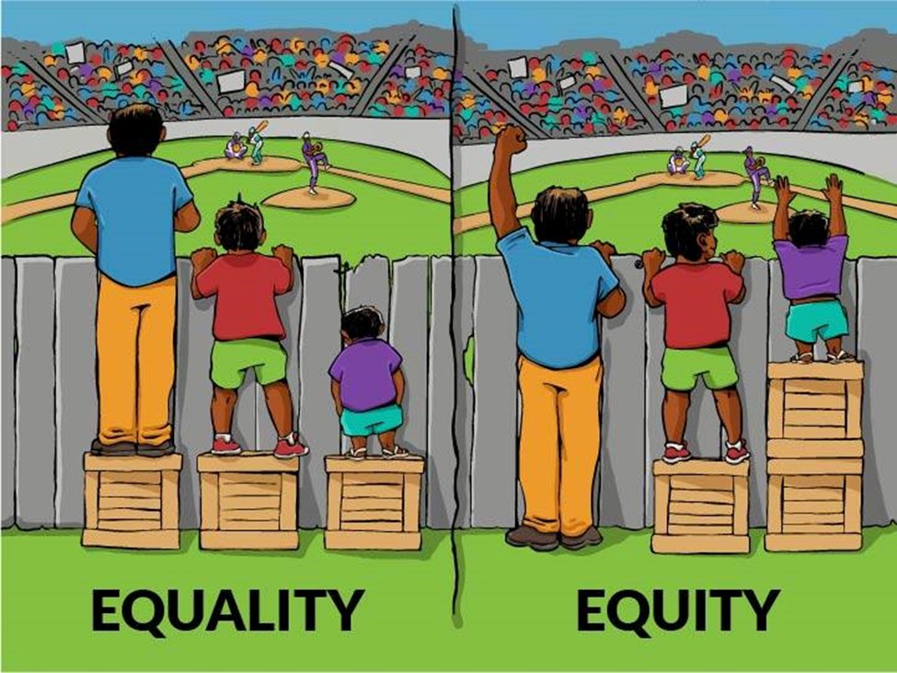
Gender inequality
Gender inequality is more pervasive than other forms of inequality. It cuts across other forms of inequality so that it is a feature of rich as well as poor groups, racially dominant as well as racially subordinate groups, privileged as well as ‘untouchable’ castes... gender inequality intersects with economic deprivation to produce more intensified forms of poverty for women than men. Gender inequality is part and parcel of the processes of causing and deepening poverty in a society and must therefore constitute part and parcel of measures to eradicate poverty (Kabeer, 2003).

Theory of triple roles
- Refers to the three types of activities including productive activity, reproductive activity and community activity. Community activity means any activity bringing together community members for the sake of community interest. Eg: Community works (umuganda), organizing wedding ceremonies, etc.
- Productive, reproductive and community roles require the use of resources. In general, women and men have different levels of both access (the opportunity to make use of something) to the resources needed for their work, and control (the ability to define its use and impose that definition on others) over those resources.

Strategic gender needs
- Strategic gender needs refer to the need that change the existing gender roles and to address equality issues. Needs that are related to changing the situation of marginalized people especially the women;
- Strategic needs may include such issues as legal rights, equal wages, and women’s control over resources etc. A few examples of activities which address strategic gender needs are:
- improving women's access to resources such as credit, land and education and training;
- enhancing women's participation in cooperatives and their access to decision-making levels;
- ensuring that women are afforded equal treatment regarding employment opportunities, promotion, wages etc.

Gender Equality Fundamental principles
- Gender equality and the Empowerment of women are at the heart of sustainable development and is enshrined in many institutions mandates and government commitments.

Exercise 1: Reflexion of gender roles in personal life
Discuss and share experience with the participant next to your personal life in relation with sexual division of labour and roles (at village life, your own home, work, religious activities, field work etc. Afterwards share your main findings in plenary

- Key messages
- “Sex” and “gender” are not the same: understand the crucial difference;
Gender gaps/inequalities do exist: show available data and facts;
Understand the implications of gender gaps/inequalities, i.e., control over assets;
Gender mainstreaming adds a “human face “to the climate change agenda;
-It is essential to integrate gender concerns into planning and implementation of climate change policies;
Gender concerns also highlight other inequalities i.e., class, ethnicity.
-The interaction between women, men and the environment is differentiated by their roles, needs, responsibilities and power relations.
-Gender inequalities affect the sustainable management of natural resources. Environmental degradation and climate change tend to increase these inequalities.
-Environmental interventions are not gender-neutral: environmental policies and projects impact men and women differently.

Lesson 2: Key concepts in Climate change

Climate change means “a change of climate which is attributed directly or indirectly to human activity that alters the composition of the global atmosphere and which is in addition to natural climate variability observed over comparable time period.
Adaptation (adaptive capacity and adaptive strategies) refers to the ability of livelihood systems to cope with or adapt to change by reducing their vulnerability through strategies such as livelihood diversification by developing the requisite skills and capacities as well as access to supporting resources such as micro-credit.
Disaster is a serious disruption of the functioning of a community or society causing widespread human, material, economic or environmental losses which exceed the ability of the affected community to cope using its own resources. A disaster is a function of the risk process: hazards + vulnerability.
Livelihoods comprises the capabilities, assets (material and social) and activities required for a means of living. A livelihood can be said to be sustainable when it can cope with and recover from stress and shocks and maintain or enhance its capabilities and assets without undermining the natural resource base.
Resilience is the capacity of a system, community or society to resist or to change in order that it may obtain an acceptable level in functioning and structure. This is determined by the degree to which the social system can organise itself, and the ability to increase its capacity for learning and adaptation, including the capacity to recover from a disaster (self- organise).
Risk is the expected damage or loss due to the combination of vulnerability and hazards. People are considered at risk when they are unable to cope with a disaster.
Vulnerability defines a set of conditions and processes resulting from physical, social, economic and environmental factors which increase the susceptibility of a community to the impact of hazards.

Lesson 3: Environment and Climate Change policy frameworks
Gender, Environment and climate change mainstreaming will be applied to:
- Rwanda green growth and climate resilience strategy
- Nationally Determined Contributions
How? Through gender mainstreaming across existing environment and climate change mainstreaming guidelines: key programmes of actions to ensure the result comprehensively address both issues of gender and of environment and climate change.
Rwanda GGCRS 2015-2030 Programmes of Action
- Sustainable intensification of small-scale farming
- Agricultural diversity for local and export markets
- Integrated Water Resource Management and Planning
- Sustainable Land Use Management and Planning
- Low carbon mix of power generation for national grid
- Sustainable small-scale energy installations in rural areas
- Green industry and private sector investment
- Climate compatible mining
- Efficient resilient transport systems
- Low carbon urban settlements
- Ecotourism, Conservation and PES Promotion
- Sustainable forestry, agroforestry and biomass energy
- Disaster Management and Disease Prevention
- Climate data and projections
The RGGCR Strategy is guided by a number of principles: Economic Growth and Poverty Reduction , Welfare and Wellness of all citizens in a growing population, Gender Equality and Equity , Sustainability of the Environment and Natural resources, Good Regional and Global Citizenship.
Nationally Determined Contributions:

International Policy framework on gender, environment and climate change:
Rwanda has specific commitments regarding environment management through ratification of the following International conventions, many of which have Gender Action Planned agenda to guide country action plans:
- The Convention on Biological Diversity (CBD) has gender considerations. In 2008, Parties to the CBD adopted a Gender Plan of Action;
- United nations Outline Convention on Climate Change (1988) , the UNFCCC and has a Gender Action Plan;
- United Nation Convention on Desertification UNCCD (1998), has a Gender Action Plan that recognised women’s important role and participation in combatting desertification and mitigating the effects of drought;
- Vienna Convention for the Protection of the Ozone Layer (2001);
- Stockholm Convention on Persistent Organic Pollutants Agents (2002) + Gender Action Plan;
- Ramsar Convention on Wetlands (2003);
- Convention on the Conservation of Migratory Species of Wild Animals (2003)
- Convention on the Prior Informed Procedure for certain hazardous chemicals and pesticide in International Trade (2003);
- Basel, Rotterdam, and Stockholm Conventions (BRS) on control of trans boundary movements of hazardous wastes and their disposal; + Gender Action Plan (BRS-GAP);
- The Kyoto Protocol to the UNCCC. The Montreal Protocol and related Kigali amendment (2016);
- Paris Agreement for Climate Change;
- Nagoya protocol;
- The Rio Declaration recognised the important role of women in environmental management and development, and Agenda 21 called for, among many other things, sex-disaggregated data and gender-sensitive databases (United Nations Sustainable Development, 1992);
- Agenda 21 (UNSD, 1992) promotes women’s empowerment and gender equality with regard to crucial issues such as land ownership, resource stewardship, education and employment.

Specific gender, environment and climate change policy frameworks

- CEDAW: Gender equality is a human right that is enshrined in a number of declarations and conventions, including the legally binding Convention on the Elimination of All Forms of Discrimination against Women (CEDAW). Rwanda is a CEDAW member country and the CEDAW particularly promotes women’s rights to credit, family planning, education, access to resources, the right to work, and participation in decision-making. It mandates countries to take “all appropriate measures to eliminate discrimination against women in rural areas to ensure, on a basis of equality of men and women, which they participate in and benefit from rural development”.
- BPfA (1995): The Beijing Declaration and Platform for Action (BPfA) includes women and the environment as one of the 12 critical areas for action and encourages governments to collect data on the impact of environmental degradation on women, as well as develop gender-sensitive databases (UN, 1995).
- Gender action plan under the UNCCD (2013): The United Nations Convention to Combat Desertification (UNCCD); seeks parties to enhance women’s role as agents of change by addressing the gender inequalities they face; to build women ang girls ’s capacities to access the resources they need to improve their livelihoods, manage land sustainably and be resilient to drought; to develop a baseline on gender related issues in land degradation and desertification and mobilise adequate resources to achieve the mentioned.
- Gender action plan under the UNFCCC: The United Nations Framework Convention on Climate Change (UNFCCC) the first linkage to gender equality was made under the Lima work programme on Gender COP20).it seeks to advance women’s full equal and meaningful participation and promote gender responsive climate policy and the mainstreaming of gender perspective in the implementation of the convention and the work of parties at all levels.
- SDGs: The Global Agenda for Sustainable development, identifies the following four main priorities for gender-environment nexus: Right to land and natural resources and biodiversity, (Goal 1,5,14 and 15); Access to food, energy, water and sanitation, (Goal 2,5,6 and 7); Climate change, sustainable production and consumption and health and well-being, (Goal 1, 3, 5, 11,12and 13); Women in environmental decision making, (4, 5, 8 and 10).
- Gender action plan under the BRS: The Basel, Rotterdam and Stockholm convention seek to address the gender issues related to the implementation of hazardous chemicals and wastes management, emphasis is put on the impact of poor management of hazardous chemicals and wastes on vulnerable groups such as women and young children. Identification of areas where vulnerable groups and sub-groups are specifically impacted e.g: e-waste, DDT, mercury etc
- AU gender policy 2018-2027: the strategy in its strategic pillar on economic justice and sustainable development recognizes that women are key mnagers of the environment and bear the brunt of natural disasters and climate change yet are not yet meaningfully engaged in climate justice initiatives. The AU strategy seeks among others to Increase women’s access to land initiatives, harness African energy resources to ensure modern, efficient, reliable, cost-effective, renewable and environmentally friendly energy to all African households, businesses, industries, industries and institutions. Work with industry leaders to set-gender targets in their firms; women’s equal participation in agri-business etc.
Key message:

Key references:
- Gender Action Plan of the Secretariat of the Basel, Rotterdam and Stockholm Conventions (BRS-GAP) for 2016-2017. 2016. Available from <http://www.brsmeas.org/Portals/4/download.aspx?d=UNEP-FAO-CHW-RC-POPS-SEC- REP-BRS-GAP-2016-2017.English.pdf> IUCN, UNDP and GGCA. 2009.
- Burns, B. and Patouris, J. (WEDO). 2014. United Nations Framework Convention on Climate Change (UNFCCC) Decisions and Conclusions: Existing Mandates and Entry Points for Gender Equality. Available from <https://portals.iucn.org/union/sites/union/files/doc/gender_cc_technical_guide.pdf>
- Training Manual on Gender and Climate Change. Available from <https://cmsdata.iucn.org/downloads/eng_version_web_final_1.pdf> UNCCD (ICCD/COP (13)/19). 2017.
- Advocacy Policy Frameworks: Gender, Drought and Sand and Dust Storms. Note by the Secretariat. Available from <http://www2.unccd.int/sites/default/files/sessions/documents/2017- 08/ICCD_COP%2813%29_19-1711042E.pdf>
- UN Environment. 2016. Global Gender and Environment Outlook. Available from <http://web.unep.org/gender/sites/unep.org.gender/files/documents/Gender%20and%2 0environment%20outlook_opt.pdf>

Lesson 4: The seven steps of Gender Mainstreaming
Integrating the gender perspective in a policy means that equality between women and men, as the overarching principle should be taken into consideration in all decisions, in each phase of the policy making process by all the actors involved.

What is gender mainstreaming?

Gender Mainstreaming is the process of accessing the implications for women and men of any planned action, including legislation, policies and programmes in all areas and at all levels. It is a strategy for making women's as well as men's concerns and experiences an integral dimension of the design, implementation, monitoring and evaluation of policies and programmes in all political, economic and societal spheres, so that women and men benefit equally, and inequality is not perpetuated. The ultimate goal is to achieve gender equality [by transforming the mainstream] (ECOSOC, 1997, emphasis added).
The seven steps of gender mainstreaming
The following steps illustrate the preparation of gender-sensitive projects, programs, and action plans (Figure 1). They provide a general guideline that can inform the gender mainstreaming process. However, the individual steps of integrating gender considerations into the policy process and project development must be specifically tailored to the country context, existing development policies and climate targets, the legal framework, the sector, and the level targeted by planned climate change measures.

Step 1: Preparation
Examine the political, organizational, and institutional foundation to integrate gender into environmental or climate policies, programs, and projects. Put in place appropriate institutional arrangements, partners, and core project team—identify the plan players and actors. Identify desired level of mainstreaming, e.g., policy, program, and project as well as the targeted measure, sector, and goals—when, what, and where? Establish the decision-making process. Finally, preparation include awareness raising among institutional partners and civil society.
Step 2: Gender analysis
A gender analysis involves collecting relevant sex-disaggregated data, identifying relevant gender issues relating to the roles of men and women and their position, capacity, and inequalities. These gender concerns and considerations are integrated into the planning, design, and implementation of a proposed intervention into policies, programs, and projects. Gender analysis needs to take place as one of the first steps of gender mainstreaming to identify gender roles, needs, interests, and inequalities. The aim is to identify, understand, and redress inequalities based on gender status, roles, responsibilities, and relations. The analysis then informs design measures in a manner that reduces inequalities and empowers both men and women to participate and ensure the measure is sustainable and effective. An analysis of gender relations and inequalities should also be undertaken at later stages of a policy, program, or project cycle to evaluate their impact on men and women.
Step 3: Problem analysis
In order to retrace the cause of possible gender inequalities, drawing a problem tree to show root causes and effects of gender issues should follow the gender analysis. The problem tree should visualize the information gathered to identify social, economic, or environmental barriers that are linked to the achievement of mitigation or adaptation goals.
Step 4: Solution analysis
Undertake a solution analysis looking at gender sensitive alternatives that best deliver the expected outcomes and impacts:
Step 5: Design
The purpose is to develop a detailed design document to guide policy, program, or policy implementation: The later can use standard project design documents which should include gender sensitive objectives, rationale, description, outputs, impact and outcomes, investment and financing plans, gender responsive implementation arrangements, and monitoring.
Step 6: Implementation
This phase involves the implementation of the activity in accordance with the plan’s objectives, design, resource allocation, implementation arrangements, and targets. Effectively involve both men and women. During implementation, as beneficiaries, experts, stakeholders. But also acknowledge gender differences in needs, roles and interests for planning its strategies. Hence Implementation phase propose gender responsive interventions and allocate adequate budget to interventions that address gender inequalities in the identified by the policy/strategy.
Step 7: Monitoring and evaluation
Prepare a monitoring and evaluation plan, based on gender priorities to be monitored: the activities of actors, the results of gender relations, the efficiency and effectiveness of the gender mainstreaming process, etc. Gender sensitive indicators of activity, outputs, outcomes and impact characterizes a gender responsive monitoring and evaluation.
The module 5 on Gender mainstreaming in planning and budgeting provides key strategies to improve women’s or men’s social economic status.

Table: Checklist gender mainstreaming in forest project cycle
Step-by-step toolkit for gender mainstreaming in forest project cycle
Project design:  Projects that involve women and address gender issues from the designing stage are more likely to provide better outcomes | - Hiring a gender expert as part of the team to contribute to the development of the action plan,  - Engaging local women in design to include their knowledge and concerns in the plan.  - Conduct a gender assessment for a sustainable forest management project. Include a mapping of stakeholders and potential partners
Project planning:  The information and results from the gender assessment are essential to prepare the Gender Action Plan | The Gender Action Plan, includes specific actions, activities and targets to address gender inequalities and advance women empowerment in forest projects. Tip: Use participatory approach to plan for the gender action plan. (learn from example of key strategies at page in module 6: gender mainstreaming in planning and budgeting).
Project implementation:  Gender-responsive project implementation ensures having the appropriate mechanisms to carry out gender-sensitive activities. | - Selecting an implementation team that is gender- balanced team at different staff levels and that will promote gender equality to guaranteeing that gender issues will be addressed during this stage.  - Provide gender training for local staff, local technical specialists and trainers, local NGOs and community members.  - Training beneficiaries and engaging women in projects activities is extremely important
Monitoring and Evaluation  Monitoring the progress is essential to assess if the project is reaching its goals or if the gender plan is meeting the targets | - Incorporate gender-sensitive indicators and targets as part of the monitoring framework,  - During evaluation process its or the evaluation of the project it is important to document good practices and learn from the outcomes regarding gender.
Impact assessment | - Evaluate the socio- economic impact of the project looking at gender perspective. This can be done by mainstreaming gender in EIA or conduct a gender impact assessment in project mid-term.

Practical exercise

Every group nominates a leader, 1-minute taker, a presenter,
All group members must participate, the leader tasks peoples: on sex disaggregated data searching, gender gap identification, and conformity to checklist criteria.
Manage your time and ask any question to the facilitator;
Working documents: 3years National strategy
At least one sector policy
Sample of budget sheet or action plan
Draft National gender policy

TASK TO DO:
- Each group is assigned any National policy relevant to E&CC (ENR, (agriculture, urbanization, water management policy, industry), and each group try come up with a gender sensitive vision and mission. (Duration: 15 minutes).
- Use the checklist to mainstream gender in assigned policy. Critical sections include (vision and mission, strategic objectives, policy principles and priorities actions to address the gender –environment &CC issues, stakeholder engagement.

Module 3: Building a foundation for Gender Analysis
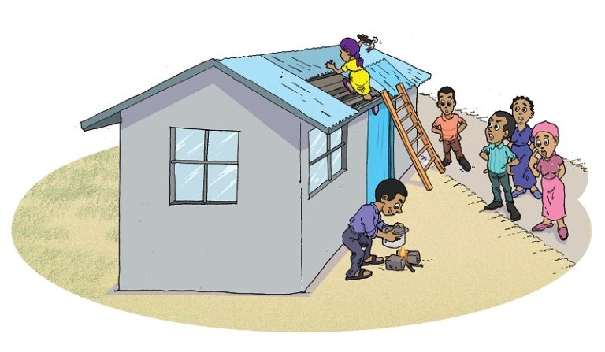
Introduction

This module introduces the gender and environment & climate change nexus, including an overview of the key definitions in gender, environment and climate change. The key linkages that form this nexus, how should gender be mainstreamed in environment and climate change for Rwanda context. The module illustrates the links between gender, environment and climate change across a range of thematic areas, translated here as priority programs of actions. This module kicks-off the seven step of gender mainstreaming after defining the approach.
Learning outcomes:
After completing the module, participants will be able to:
- Understand the objectives of the course
- Explain how gender equality leads to environmental benefits and provide concrete examples.
- Describe the links between gender and biodiversity, climate change, land degradation, chemicals and waste and international waters
- Understand what gender analysis is and how it is conducted;
- Using different gender analysis tools
- Every participant can practically use a tool of choice to guide his / her gender analysis for an elementary activity in environment and natural resources.
Activities:
- The course consists of:
- plenary lecture session;
- Participants discussions and experiences sharing;
- literature study and review (hands out);
- group work and feedback presentations;

Lesson 1: What is gender analysis?

Gender Analysis is a systematic way of looking at the different roles of women and men in development and at the different impacts of development on women and men. Essentially, gender analysis asks the 'who' question: who does what, has access to and control over what, benefits from what, for both sexes in different age groups, classes, religions, ethnic groups, races and castes?
Gender analysis also means that in every major demographic, socio- economic and cultural group, data are separated by sex and analysed separately by sex.
A gender focus - that is looking at males and females separately, is needed in every stage of the development process. One must always ask how a particular activity, decision or plan will affect men differently from women, and some women or men differently from other women and men (Rani Parker, 1993). Looking at how water management tasks are divided across the sexes and age groups shows for example on which aspects water projects need to work with women or with men, as within families, different categories of women, and men, tend to have different tasks, decision-making power and knowledge (van Wijk, 1998).
When do I know there is a Gender Gap?
When noted any disproportionate difference between men and women and boys and girls, particularly as reflected in attainment of development goals, access to resources and levels of participation. A gender gap indicates gender inequality.
Social Norms and Gender Roles: What is gender-roles about?
Social and behavioural norms that, within a specific culture, are widely considered to be socially appropriate for individuals of a specific sex. These often determine the traditional responsibilities and tasks assigned to men, women, boys and girls. Gender-specific roles are often conditioned by household structure, access to resources, specific impacts of the global economy, occurrence of conflict or disaster, and other locally relevant factors such as ecological conditions
Gender and social norms
Accepted attributes and characteristics of male and female gendered identity at a particular point in time for a specific society or community. They are the standards and expectations to which gender identity generally conforms, within a range that defines a particular society, culture and community at that point in time. Gender norms are ideas about how men and women should be and act. Internalized early in life, gender norms can establish a life cycle of gender socialization and stereotyping
Analysis of access and control over resources
Resources are critical to people’s identities and livelihoods and to advance autonomy, agency, and rights. Yet, historically, due to gendered divisions of labour, patriarchal cultural norms and laws and economic inequalities, women in all their diversity have been denied access to resources such as education, health services, credit, land and technologies. Assessment of access to and control of resources has been a fundamental tool of gender analysis.
Access to land: Differences in access rights to land were observed, not only between women and men, but also between women. The study revealed that the access rights of widows with children and biological daughters were slightly more secure than those of step or adopted daughters, widows without children, women with physical disabilities and women involved in a consensual relationship. Access rights of all categories, however, strongly depended on the presence of a father or husband and/or their relationships with his relatives.
Control over land: While most men and women had access to land, few actually had control over the land they cultivated, as this was strongly linked to land ownership. Land ownership was largely vested in lineages, clans and family units. Control over land was largely ascribed to men by lineage, clan or stool heads due to the higher status allocated to them by society, the advantages accorded to men through the patrilineal descent system, the leadership roles executed by men at the household and community level, and their relatively better financial positions.

Analysis of Gender and Decision-making powers

Those who have decision-making powers with regard to land have greater access to and control over the land. Traditionally, decisions concerning land issues are taken by men. This practice, however, is being challenged. An appeal was made to give women a chance to prove their capabilities as leaders and major decision makers. Furthermore, women were encouraged to organise themselves in order to enhance their opportunities to participate in decision-making processes.

Why is Sex disaggregated data important?
Because data that is cross-classified by sex, presenting information separately for men and women, boys and girls. When data is not disaggregated by sex, it is more difficult to identify real and potential inequalities. Sex-disaggregated data is necessary for effective gender analysis
Gender indicators
Criteria used to assess gender-related change in a condition and to measure progress over time toward gender equality. Indicators used can be quantitative (data, facts, numbers) and qualitative (opinions, feelings, perceptions, experiences).

Lesson 2: Gender Analysis Toolkit
Gender analysis in environment and climate change can use multiple gender analysis tools. The main gender analysis tools include but not limited to: The Harvard Analytical Framework and the Moser Gender Planning Framework. A Socio-economic and Gender Analysis Framework, was created by the Food and Agriculture Organization. ENERGIA has created a manual for gender mainstreaming in energy named: Mainstreaming Gender in energy.
  - The Harvard Gender Analysis Framework,
This gender analysis tool takes into consideration productive/livelihood activities for women and men, roles and relationship between men and women, access to benefits and control of resources. C

c
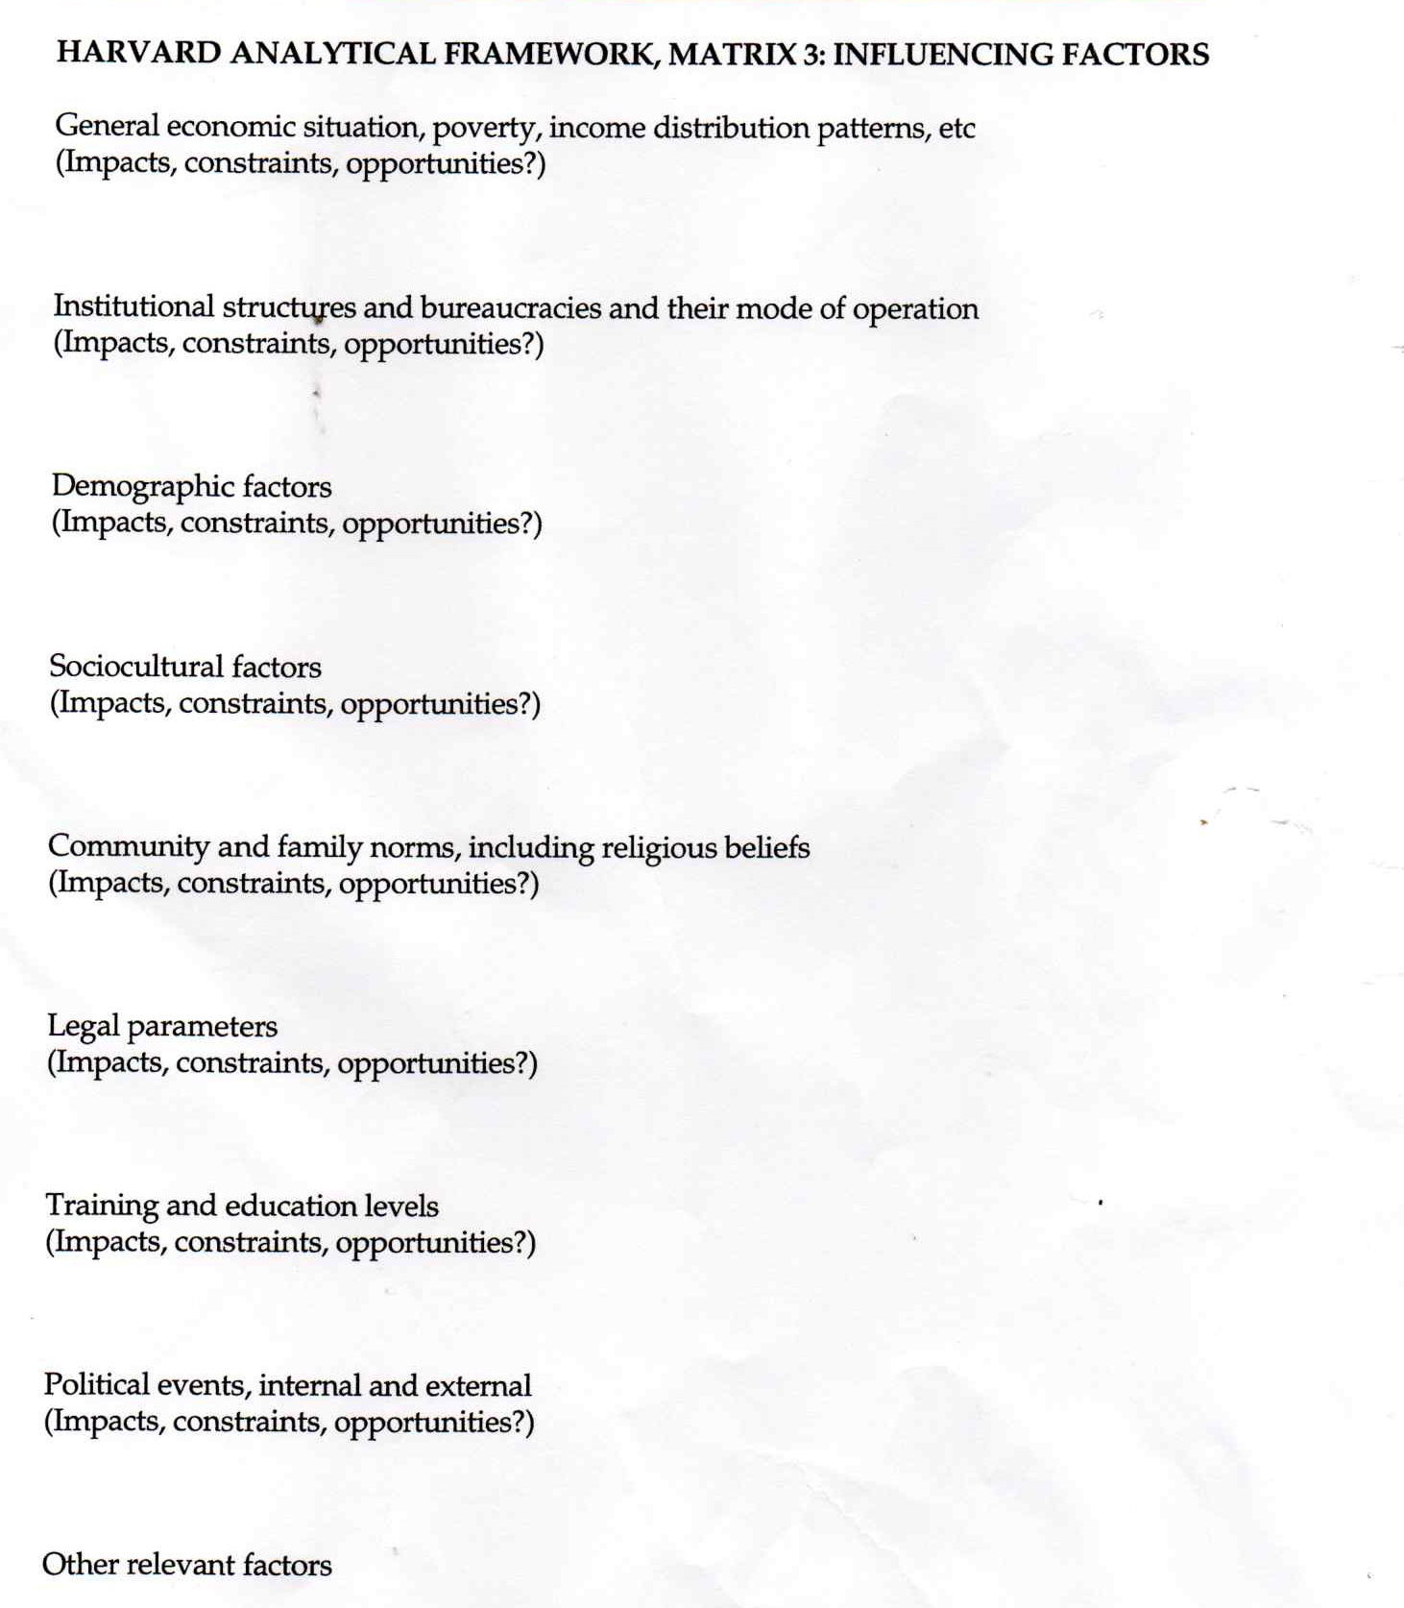

  - Practical tools initiated by USAID also help gender analysis through the following:
Identification of gender-based constraints per actor and activity
Actors by type of program of action | Description of activities under each intervention program of | Responsibilities/roles and level of implication by gender |  | Which constraints are faced that limit access and control of resources for the activity carried out by gender
Actors by type of program of action | Description of activities under each intervention program of | M | F | Male | Female
Activity 1
Activity 2
Activity 3
Regarding constraints and strategies to address them, the following tool can be used.
Formulate actions to address the gender-based constraints
List the most important gender based-constraints for the program | Factors contributing to identified constraints | What actions might address the constraints to achieve more equitable outcomes and more environment sustainability benefits?

Practical exercise

Programme subject for gender analysis:

Fish farming activity in Kivu lake

Girinka programme

Transport system development in a new secondary city (model green city)

Poverty reduction through business development project near Mukura forest (Rutsiro District)

Conduct research on gender-based Households vulnerability mapping

Waste management and recycling project in Kicukiro district

Land consolidation for maize and vegetable intensification project in Yanze watershed including marshland

Each group select any project or programme of choice

TASK TO DO:

- Each group identifies the environment and climate change contribution/issues related to selected project. Consider E&CC in relation to the 14 PoAs. E.g: link Girinka with organic fertilization
- Each group select a gender analysis tool and use it to carry out gender analysis in one of the above projects. E,g: Harvard gender analysis tool, GE matrix, etc (duration 30 min)
- Basic gender analysis elements to consider:
Access to and control over resources, assets, benefits;
Practical and strategic needs,
Gender roles and Division of labour by gender,
Triple role.
Related financial or other government opportunities

Key references:

- USAID, 2009, Promoting gender equitable opportunities in agricultural value chains: a handbook. by Deborah Rubin (Cultural Practice LLC) and Cristina Manfre and Kara Nichols Barrett (dTS), p. 101-106
- https://trainingcentre.unwomen.org/mod/glossary/view.php?id=36
- Anita Ramsak, 2010. Gender equality and Gender mainstreaming: Manual for Trainers.

Module4: Critical Areas for mainstreaming Gender, Environment and Climate Change
Introduction

The module illustrates the links between gender, environment and climate change across a range of thematic areas, translated here as programmes of actions for green development and climate resilience. The module 3 introduces how gender can be mainstreamed in integrated projects. Instead of discussing individual PoA; thematic areas are presented here as tutorial, each of them integrated more than 2 PoA. For each theme, the manual highlights gender relations through a gender situation analysis, key gender issues, entry points for addressing the gap and propose related gender sensitive indicators. This module present 6 sessions of critical areas for gender, environment and climate change mainstreaming:

  - Session 1: Gender mainstreaming in Sustainable, Diversified Intensification of Agriculture
  - Session 2: Gender mainstreaming in integrated water resources management
  - Session 3: Gender and energy efficiency
  - Session 4: Gender and pollution management in low carbon urban systems
  - Session 5: Gender sensitive approaches in sustainable forest, agroforestry & biomass management
  - Session 6: Gender mainstreaming in climate change
  - Session 7: Gender, green industry, wastes and Chemical Management

Learning outcomes:
After completing the module, participants will be able to:
• Understand the objectives of the course
• Describe the links and influence between gender and integrated program of actions for green growth and climate
resilience
• Explain how gender specific inequality leads to environmental degradation and provide concrete examples.
• Understand which key gender indicators to measure progress of mainstreaming

Activities:

The course consists of:

- Plenary sessions;
- Video material
- Group discussions and experience sharing
- Case study example
- Review of recommended literature

Lesson 1: Gender mainstreaming in Sustainable, Diversified Intensification of Agriculture
;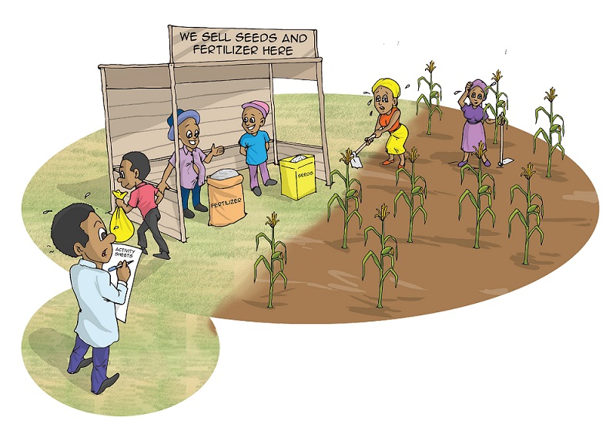
Introduction
Sustainable intensification of agriculture programmes seek to enhance responsible food production while preserving the natural ecosystem and maintain the ecosystem services. The production comprehensively include main interventions of erosion control measures, marshland irrigation (and hillside) within IWRM framework, farmers using mixed organic and inorganic fertilizers based on nutrients needs assessments for specific land units, sustainable land management, climate smart agriculture, farmers receiving weather and climate information products/services, integrated pest management (IPM) include among others the use of improved seeds (high yields seeds, limits external-inputs, pest-resistant and climate-adapted crops).
Sustainable farm and small-scale farm management interventions with an explicit gender lens can help reduce women’s poverty by enhancing their socio-economic empowerment; by reducing climate vulnerability in the production and marketing of seasonal crops where women dominate; and by promoting legal reforms in land tenure, organic inputs access and institutional development through enhanced training and leadership development for women.

Gender situation analysis
Rwandan customs attributes men and women different roles in farming activities: while the men focus on energy taking tasks such as ploughing, and business activities to sell the crop yield, tree planting; women are attributed the roles ploughing, planting, weeding, pruning, harvesting and post harvesting that keep her busy the whole farming season and therefore, a higher dependency on natural resources. Additionally, the customs gave the women and girls much involvement in reproductive works time-taking and unpaid tasks: finding and cooking daily family food, babies and child care, cooking fuel and water fetching responsibilities. These responsibilities resulted from unequal sexual division of farm labour among the family members, resulting in unequal exposure to skilled farm technology, trainings, financial services and education, market, agriculture investment and benefits from sustainable agriculture.
Gender issues in sustainable intensification of agriculture

Access to land ownership: Lack of land ownership titles and formal tenure limit women’s decision-making power for sustainable agriculture and over the resources produced. Studies have shown that land rights empower women by improving their control over household income and bargaining power over resource allocation; and increasing their participation in the community and institutions (World Bank 2009a).
There is a gender gap in agriculture productivity Recent study carried out by UN Women, UNDP-UNEP PEI and World Bank, 2018) in Uganda, Kenya, Tanzania has measured the gender gap in agriculture productivity. This study revealed that there is gender based differences in agriculture productivity in Rwanda, Uganda, Kenya and Tanzania. Raised determinants include environmental factors. Key raised constraints facing the women farmers include climate variability, the gender differences in access to productive inputs, differences in women and men’s access to returns from productive inputs, but also the endowment effect (age, education, HH size and dependency ratio). Women can face discrimination in the market when marketing their produce directly, and also can lack of language skills, access to information or training (Carr 2008; Bandiaky-Badji et al 2016).
Gender of the farm manager is determinant of Ecological farm. Women managed farms and male managed farm: According to the DHS, (NISR, 2014-2015) The average Rwandan household has 4.3 members. Three in ten households are headed by women. The research also revealed positive Gender –environment interactions for female managed farms (FMF). The females managed farms are found to be more beneficial to farm ecology as females spend 25% less on fertilization and insecticides. However, female managed farms are 10.5% smaller than those managed by males, which could limit the investment decision on small plots.
Agriculture workforce: Women are more likely considered invisible farmers and men are more seen as paid farm workers. Women and men have different household responsibilities due to the gender division of labour which structures their priorities and income. It also affects how decisions are made and resources managed. Women mostly involve in unpaid care and domestic work. Men tend to engage in food commercialization and other high-value activities to provide the household’s main income
Climate change impact on farm is not gender-neutral: Studies revealed that reverse impact from climate variability affect women and men differently. Women tend to be more vulnerable to climate change as primarily relying on natural resource for food, fodder, water, nuts, medicinal plant and fuel energy for cooking. Environmental and climate policies and projects impact men and women differently.
Limited women’s participation in upper levels of the agriculture value chain: Women’s participation in value chains is usually limited to production, harvesting, post harvesting and small-scale retail trade, while men dominate larger businesses and tend to engage in higher- value chains. As agri-processing become more capital-intensive, or as the scale increases, women’s participation tends to decrease.
Women’s time poverty family size concerns limit their access to and use of existing opportunities for agriculture inputs and investment. Family planning (in relation with HH size) by education DHS, the bigger the family size, the heavier is the work burden spent on unpaid care work and the lower the farm productivity and child nutritional status.
Women’s work burdens within the household limit the time women can allocate to productive farming and income-generating activities (Grassi et al 2015; Colfer et al 2014). Women are frequently engaged in activities that are undervalued, including unpaid family and farm labor and work in the men’s fields (Shackelton et al 2011; FAO, n.d.a; Kiptot 2015).

Entry points for gender mainstreaming along in policy or planning cycle -Rwanda
In line with NST1 and Rwanda environment and climate change sub sector priorities, the following entry points are proposed:
  - Target women to participate in public works (jobs), to sustainably stabilise rivers, roadsides and steep slopes with protective structures and agroforestry.
  - Train smallholder farmers through mainstreaming agro-ecology and climate smart practices & IPM into existing extension system (FFS and farmer promoters) with inclusion of both men and women:
  - Train women to be trainers and Farmer Promoters, local seed multipliers to better engage in sustainable agriculture and sustainable land management practices.
  - Address gender barriers for women participation in cash crop production and processing (e.g.: gender sensitive sanitation, adequate clothing and child care facilities in tea plantation proximity and timely collection of green tea that consider gender roles;
  - Train women’s groups to engage in organic farming for horticulture production.
  - Developing credit enhancement and micro-finance programs specifically targeting women and small-scale farmers for access to small scale irrigation equipment preferably using clean energy (solar).
Sample Gender Sensitive Indicators
The proposed gender-environment and climate change indicators are source from existing M&E framework for environment and climate change. In addition, the key issues related to gender and sustainable agriculture in line with international policy framework and SDGs are proposed
 | Sample gender sensitive indicator
1. | Percentage of workers in public works by sex (at least 40%: F).
2. | Small scale irrigation farms, and hillside irrigation by sex of farm manager
3. | Number of EIA study include gender impact conducted for agricultural projects in marshlands
4. | % of farmers using mixed organic and inorganic fertilizers based on nutrient needs assessment for their specific land unit by sex
5. | % Farmers who practice integrated pest management (IPM) by sex of user. Percentage of farmer promoters (FP) and trainees by sex;
6. | Percentage of farmers receiving weather and climate information products/services by sex
7. | Number of markets constructed/national product ﬂows and having included EIA and social impact in their studies
8. | Reduced poverty and increased livelihood security Income change from markets constructed/national product ﬂows, irrigated lands and from local agro processing by type of activity.
9. | Citizens (men and women) satisfied with land services increased by gender.
 | % of male and female representation among land committees;
10. | % of women that have accessed loans using land as collateral;
Other gender indicators have been proposed to measure the gender impact and transformation in traditional gender relations but also in securing land rights and inclusion in land governance.
Reduced poverty and increased livelihood security Income change from land-based activities (agriculture) among households, disaggregated by sex of head of household.
- Increased women’s empowerment: Changes in access to land property resources disaggregated by gender
- Change in household income, disaggregated by sex of head of household, No. and % of people with improved livelihoods, disaggregated by sex of head of household, change in women’s HH roles and activity
- No and % and % of people who adopted cash crop by sex and crop type.
key indicators for Land ownership, land services and control over land:
Indicator | source
Proportion of total adult population with secure tenure rights to land, with legally recognized documentation, and who perceive their rights to land as secure, by sex and by type of tenure. | SDG 1.4.2/RLMUA
Proportion of total agricultural population with ownership or secure rights over agricultural land, by sex;  Share of women among owners or rights-bearers of agricultural land, by type of tenure | SDG 5.a.1/RLMUA
% of compliance of land use development plans to the NLUDMP (50% women involved) | SSP/RLMUA
Citizens satisfied with land services increased by gender | ENR Gender strategy/RLMUA
% of women that have accessed loans using land as collateral | GMO/MFI –BNR
Number and % of women and men involved in landscape rehabilitation initiatives | MINAGRI /RWFA
% of women and men involved in landscape rehabilitation management supervisory committees | MINAGRI/RWFA
Private land title by sex of owner | RLMUA
Initiative for utilization of organic fertilizer that involved women and men farmers | MINAGRI
Women’s participation in land governance bodies, by sex by cell/district/national | SDG/ RLMUA

Case study: gender mainstreaming in sustainable land management
Issue: In Uganda, unsustainable land use practices in rural communities can be detrimental to the productivity of the land and subsequently decrease the income of families who own and maintain the land. In this context, local communities need to receive relevant information and education linked to sustainability. In Uganda, women make up most farm group members.
Action: The sustainable rural livelihoods programme, established in 2004 in Uganda’s Kamuli district, was designed to improve food security, nutrition and health by employing farmer-to-farmer training. Farmer field schools have proved to be a participatory and effective way of empowering and transferring knowledge to women farmers about crop varieties, livestock management and pest control technologies.
Impact: The programme has resulted in increased knowledge and skills among women in improved nutrition, food security and health. Women have also gained wide respect in their community and become involved in farm groups and marketing associations.

Key resources
- NST1, 2018-2023
- GMO, 2017. Gender Profile in Agriculture sector
- UNWOMEN, 2019. The Cost of Gender Gap in Agriculture Productivity in Rwanda
- UNCCD. 2017. Turning the Tide: The gender factor in achieving Land Degradation Neutrality.
- UNDP Gender Strategy (2018-2021)
- UNEP, UN Women, PBSO and UNDP. 2013. Women and Natural Resources Unlocking the Peacebuilding Potential.
- UNEP and IUCN. (2018). Gender and environment statistics: Unlocking information for action and measuring the SDGs. UN Environment, Nairobi, Kenya

Lesson 2: Gender Mainstreaming in Integrated Water Resources Management
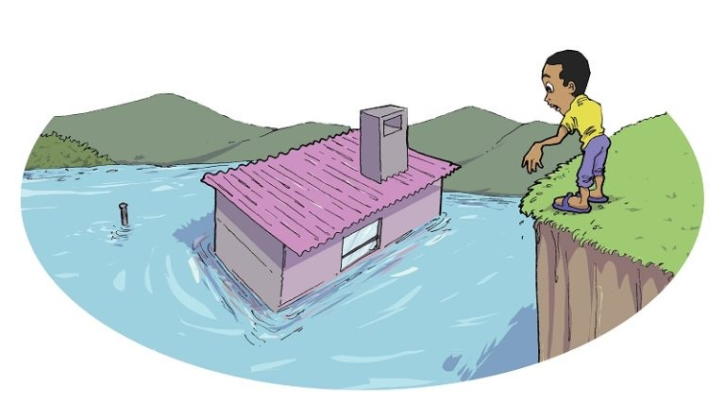
The concept and principles of IWRM were articulated at the International Conference on Water and Environment held in Dublin in 1992. IWRM is a cross-sectoral holistic approach to water management, in response to the growing competing demands for finite freshwater supplies. It is an approach that aims to ensure the coordinated development of water, land and related resources to optimize economic and social welfare without compromising the sustainability of environmental systems (Global Water Partnership, 2000). Policy makers, analysts, international organizations and governments have sought consensus on principles to guide the setting of priorities, policy making and the elaboration of specific initiatives in IWRM. Due to the pivotal role of women as providers and users of water and guardians of the living environment, it has been reflected in IWRM key principles:
“Women should be recognised as central to the provision, management and safeguarding of water.” (Dublin principle 3).Acceptance and implementation of this principle requires positive policies to address women’s specific needs and to equip and empower women to participate at all levels in water programmes, including decision-making and implementation. This has been reflected in the institutional arrangements of the development and managements of water resources. However, inadequate involvement of both women and men has hindered programmes and projects aimed at addressing sustainability in water resources management. Community participation and management approaches have failed to address these issues. Where resources are scarce, there is competition for supplies, and those at the lowest end of the power spectrum - poor women and men - will go without. Unequal power relations place women in a disadvantaged position. Applying a gender analysis helps water sector agencies allocate their resources better to meet the needs of different women and men and marginalized groups.

Gender situation analysis: Who does what?
Often, in sub Saharan Africa, women are attributed the role of home care and food cooking, thus are responsible for water supply for domestic use. Therefore, women and girls still spent the first 2–3 hours a day collecting water from either public taps or water sources rather than taking part in educative and income generation. Besides, as the majority of agriculture workforce, they are key pivots of water management and users especially in unvalued or less productive purposes. While men have control of the decisions in water resources management compared to women, they are also more visible in more productive water use (cash crops, forest, irrigated farms).
What are gender issues in IWRM?

Knowledge about sustainable water resource management, conservation, quality and storage methods mostly ignore women knowledge and training sometimes don’t include the woman. Gender division of labour affect access to training and information Women and men have different household responsibilities due to the gender division of labor which structures their water use priorities offer higher commercial benefits (Kiptot 2015).
Limited access to drinking water and sanitation have gendered impacts that are more likely to affect women than men. In order to assume their role as food providers for the family, women mainly engage in cleaning and hygiene tasks. Besides, women are the main caregivers of children and ill family members and are responsible for providing water. Need of integrated and inclusive approach for improving access to safe drinking water (unpolluted) and sanitation contribute to empower women, as it frees them to engage in other tasks.
Power relations in households influence inequitable benefits from water productivity and sustainability. Women are often more involved in seasonal crops using traditional practices, yet research has shown that men are more oriented in cash crops and are at the forefront when it comes to selling the farm produce. Lack of access to farm earnings limit women’s power and access to finance for engaging in productive inputs or in making any investment in land management structures. while men control the production and commercialization of more profitable water resource use, though this can vary among communities
The inherent linkage between land management and water challenges their sustainability when women lack land ownership rights or control over its use. The financial status of women headed households also limit the investment on land for water resource management (forest, soil erosion measures, radical terraces etc). Landscape restoration measures requires decision making and choice of the measures by the land lord this privilege is mostly attributed to men.
Limited women’s participation in water governance bodies at central and community level: Inadequate involvement of both women and men in water committees constrain their voice and influence in decision making. Poor women face cultural constraints that prevent women from speaking in public and economic constraints against allowing the poor to voice their water needs. The involvement of women water users in stakeholder consultations and forums demands specific attention and approaches. The current tools used in multi-stakeholder IWRM consultations are mainly suited for an educated, literate group, and will require adaptation for use at the local level.
Power relations also influence the way water is allocated and the choice of water management technology. An irrigation pipeline is generally associated with productive use of water, and men have more influence than women over the utilization of the resources. A hand-dug well on the other hand is generally associated with women’s domestic use of water. While this use can be considered productive, and provides benefits to women and men, it may not be given a priority. The decision-making mechanisms and politics associated with water allocations have different implications for men and women.
Women’s time poverty and work burdens for water collection at long distances limit the time women can allocate to productive or income-generating activities from water resources. Women are frequently engaged in activities that are undervalued, including unpaid family labour and work in the men’s fields. Women lack of financial skills, access to information or training (Carr 2008; Bandiaky-Badji et al 2016).

Rwanda entry points for gender mainstreaming along in policy or planning cycle
There appears to be a correlation between weak water governance, persistent poverty and inadequate access to water for vulnerable groups, leading to stunted development. Good governance can have positive impacts on gender inequalities, including the following:
- Introducing inclusive and fair rules, institutions and practices governing social interactions to improve outreach to the vulnerable, such as poor men and women;
- Ensuring that women are equal partners with men in decision making over development, use, technology choice, financing in water sector;
- including women and men in water management committees for catchment management and restauration; This inclusion should be extended to community-based organizations, women dominated associations and vulnerable groups, for planning et design.
- Reduce wood biomass energy through use of efficient technologies (cooking energy and tea factories), increase land under agroforestry, included women in forest/landscape governance.
- Consider including women’s empowerment through water management technology access, and trainings; and financial inclusion (loans to cooperatives, productive jobs); Incentives for inclusion of women and poor HH among the beneficiaries of technologies for enhancing water productivity such as solar pumps, irrigation materials, RWH etc
- Community awareness raising for environment and gender roles transformation linkages.
Regarding the inequity of productive and non-productive water challenges, should be incorporated into the assessment of relative economic values of water resources to allow for the understanding and consideration of the interdependence between productive and domestic water.
Sample Gender Sensitive Indicators
The proposed gender-environment and climate change indicators are source from existing M&E framework for environment and climate change.
Sample gender sensitive indicator
Proportion of households with RWH systems by sex of HH head
Access to and use improved drinking water, by source, by type of household and by district
% of women and men participation in cash crops production, and small-scale irrigation
IWRM training beneficiaries (experts and farmers) by sex pf participants (water quality, recycling, storage, conservation, agroforestry) , including practical FFS
Off-farms jobs activity created by sex
Proportion of water catchments with:
a) functioning WRM committees by sex of member
b) adaptive management plans
% of implementation of approved climate smart catchment management plans (with community-based approach)
Number of Water User Associations established to ensure responsible and equitable water use at the community level and proportion by sex
% of water users with permits issued monitored for compliance by category of users
Other gender indicators have been proposed to measure the gender impact and transformation in traditional gender relations. These may require conducting researches for specific projects/programme.
- Reduced poverty and increased livelihood security Income change from non-productive activities to productive cores among households in catchment areas, disaggregated by sex of head of household. change in women’s HH roles and activity
- Change in household income, disaggregated by sex of head of household,
- Increased productivity for women and men after adopting an improved IWRM measure disaggregated by sex, No and % and % of people who adopted an improved technology by sex, Change in income income received from adopting improved technology by sex of forest owners.
- Increased employment opportunities for women and youth: No and % of jobs generated by catchment management activities disaggregated by sex, Evidence of the type of incentives designed to recruit women,

Case study: Gender-related impacts of water supply interventions in north-west India
A case in north-west India of providing piped water supplies to families in remote contexts found even with a source of water located closer to home, women still spent the first 2–3 hours a day collecting water from public taps as revealed by time budget analysis and direct observation by researchers. While women no longer needed to negotiate the steep terrain of surrounding mountains to collect water, the volume of water they carried home had increased with the introduction of the public taps. This was found to be as a result of men’s expectations that they could now have baths at home, while previously they were conducted at public baths. This case shows that the delivery of a water project did not in and of itself result in changes in gender norms, or a reduction in women’s workload despite the introduction of public taps. The case points to the need to look beyond outputs to assess the impacts and outcomes of water supply interventions.
Source: Narain (2014).

Case study: Empowering women in Catchment Governance in Rwanda
Catchment committees are provided by the Rwandan Water Law (2019). In 2017, Ministerial Instructions for establishment of Catchment Committees (CC) required including one representative of the National Women’s council at district level. Henceforth, these committees are established for each the four demonstration catchments (level 2): Upper–Nyabarongo, Sebeya, Nyabugogo and Muvumba.
While catchment plans for the mentioned demonstration catchments are operational, community-based approach was adopted for participatory planning of catchment interventions. interventions included namely: landscape restoration for erosion and flood control, improving drinking water sources, agroforestry etc. A total participation of 5,870 men and women water users in community meetings was recorded. Alongside the community elected a total of 151 implementation committees at micro catchment level, with 30% female quota in each committee. The total female representation in those implementation committees was 31%. Gender balance in water resource management is expected to include both women and men’s interests and water needs for productive and domestic use. Planned actions of increasing HH access to improved water sources, adoption of rooftop rainwater harvesting (RWH) and distribution of improved cook stoves (ICS) and job creation through erosion control and agroforestry are expected to result in gender roles transformation due to a reduction in women’s workload.
MCAP Report 2019, RWFA –Water for Growth Rwanda

Source: Narain (2014).

Key message: The sustainable management of water resources must involve both women and men as key stakeholders and proactively address their specific needs and interests.
Key resources
- National IWRM Master Plan
- Gender strategy in IWRM
- GWP, 2017. Gender equality and inclusion in IWRM
- UNDP, GWA, 2006. Resource Guide Mainstreaming Gender in Water Management
- UN Environment. 2016. Global Gender and Environment Outlook, 2016. Available from <https://www.unenvironment.org/resources/report/global-gender-and-environment- outlook>
- 2019, RWFA. Micro-Catchment Action Planning Report in DC, Water for Growth Rwanda.

Lesson 3: Gender and Energy efficiency
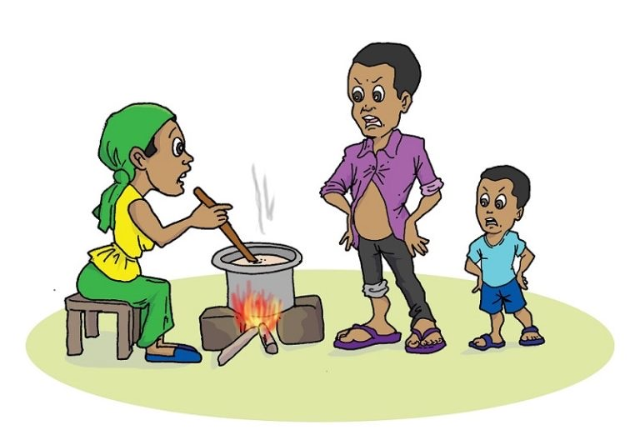
Introduction
Sustainable and efficient energy seeks to increase small scale energy access in rural areas, through 65.5% Rwandan household still don’t have access to the electricity grid and is dependent on wood for fuel. There is much potential for off-grid or mini-grid generation from biogas, solar PV and micro-hydropower. This should be utilised to increase access to electricity in rural areas especially for reducing the dependence on wood fuel (firewood use is 82%) and supporting economic development. Increasing small scale energy generation in rural areas, with non-biomass cooking energy being one of the entry points.

Gender situation analysis
In communities where HH dependency on fuel wood is high, women’s control over energy resources may be more commonly cantered on management and use of fuel wood. Gender roles attributed women as food providers for the family, women mainly engage in cooking, cleaning and home care tasks. Besides, women are the main responsible for meals preparation for children and all family members and are responsible for providing water. Biomass energy remains the main source of energy in sub Saharan Africa including Rwanda.
Gender issues in sustainable energy

Limited access to electricity and alternative energy sources increases pressure on forest for cooking energy: Studies have shown that the, increases the dependence on wood fuel especially in the rural areas make women the key users of fuel wood increasing the pressure on forest. This is a threat to forest, land and water resources and related ecosystems services.
Traditional cook stoves using fuel wood and biomass present health risks to the main users: most of the users are not aware of the health risks from using unimproved cook stoves.
Limited women’s participation in energy decisions and technology: Women’s participation in energy is usually limited to firewood collection, cook stove use and small-scale charcoal retail trade, while men dominate larger firewood and charcoal businesses. Women’s participation also diminishes when it comes to policy making and decision making in energy sector.
Biomass energy collection and Gender division of labour worsen women’s time poverty and physical safety concerns. Social norms have determined gender roles. These roles determined how women and men divide different household responsibilities, resulting in unequal division of labour and unequal share of unpaid care work. Women’s work burdens within the household include fuel wood collection which limit the time women can allocate to income-generating activities. Besides, women can face gender based violence when they engage in firewood fetching at late hour.

Entry points for gender mainstreaming along in policy or planning cycle
In line with National energy policy priority actions and Rwanda environment and climate change sub sector priorities, the following entry points are proposed:
- Engagement of both women and men in private operators for green energy production and distribution and maintenance (green charcoal, solar);
- Considering gender issues at every stage of the energy project cycle and in all major sub-sector strategies and action plans developed;
- Proactively targeting female-headed households in awareness-raising and behavioural change programs focused on sustainable energy and clean cooking technologies;
- Undertaking education, outreach, and awareness-raising activities focused on identifying and altering cultural norms, behaviours, structures and practices that can lead, whether intentional or not, to inequitable energy access;
- Developing credit enhancement and micro-finance programs specifically targeting women for driving investments in clean energy technologies, such as solar powered.
Sample Gender Sensitive Indicators
The proposed gender-environment and climate change indicators are source from existing M&E framework for environment and climate change. In addition, the key issues related to gender and sustainable energy have been identified by the Gender Monitoring Office. The proposed gender indicators for gender and energy measure: efforts to reducing women’s health risks due to exposure to unsafe cooking energy, reducing the use of biomass energy, women access to green energy employments, sustainable energy production and consumption women participation in energy sector planning and decision-making.
 | Sample gender sensitive indicator
1. | Household with primary reliance on clean fuels and technology or “Green” energy technology by main user
2. | Time used by households for collecting firewood for household consumption;
3. | Main source of lighting by sex of household;
4. | Cook stove distribution by type of cook stove (ICS, LPG) and by main user;
5. | Awareness on health consequences of non-improved cook stoves;
6. | Participation in community awareness on health impact of polluting energy;
7. | Perception on women’s safety due to lack of energy and capacity to drive energy efficient use/practices;
8. | Women’s participation in professional and Executive managers of national energy utilities, by sex

CASE STUDY: Women solar engineers trained by the Barefoot College
Issue: In Rajasthan, many of the villages have limited access to electricity and to viable cooking options. Women in these communities resort to using kerosene and fuel wood that are especially dangerous as well as being hazardous to the health of their families and the environment.
Action: The organization trains these women to become solar engineers and to use solar cookers, solar desalination plants and water heaters. They then go back to their villages and support the installation of solar lamp kits. Each household invests the same amount previously spent on kerosene, candles or batteries in maintaining and upgrading the solar installation.
Impact: Once installed, the solar lamps or kits are managed by a committee run by four women and three men. The women solar engineers receive a monthly salary for reparations. In the last decade, 604 women solar engineers trained by the Barefoot College have electrified 1,083 villages in 63 countries in Latin America, Africa, the Middle East, Asia and the South Pacific islands, bringing domestic lighting to over 45,000 houses. Source: UN Environment. 2016. Global Gender and Environment Outlook. Available from. https://www.unenvironment.org/resources/report/global-gender-and-environment- outlook

Key resources
- REMA, 2015. Rwanda Green Growth and Climate Resilience Strategy (RGGCRS)
- GMO, 2018. Gender Profile in Energy sector.
- ENERGIA International Network on Gender and Sustainable Energy NISR. EICV5 2016/2017. website
- CIF, 2017. Gender and sustainable forest management, entry points for design and implementation.
- National Energy Policy
- DHS 2014/2015
- IUCN Training manual: gender and Climate change

Lesson 4: Low carbon Urban Systems: Gender and Pollution Management
Introduction
Air quality management objectives contributes to threefold programmes of action but all integrated in sustainable urban development: (1) law carbon urban systems, (2) resilient transportation system and (3)green industry and private sector development. The air quality management seek to reduce green gas emission and reduce other chemical pollution from inorganic or chemical waste that contribute to air pollution. There is much potential for green cities development, cutting vehicle emissions from road traffic and the emissions from industrial sources but also the emissions from domestic sources.
Gender roles situation analysis?
Domestic emissions are related to cooking energy; women mainly engage in cooking thus domestic emission have a direct link with gender. Studies found that women carry out HH chores are mostly, thus found in the household neighbourhood due to their limited mobility. Industrial zones are mostly located far from residential areas, and therefore women are less represented in industry sphere neither as employees nor private owners However, women are found to be the main users of public transport for daily activities. Gendered power structure influences the limited participation of women in urban planning, design and decision making.

Gender issues in law carbon urban system

Limited HH access and affordability of climate smart technology for vulnerable and women headed HH: Without social protection and inclusion, it is hard to afford the cost of efficient cooking and lighting energy (solar and biogas), rooftop rainwater harvesting, benefits more the women as home care takers. Besides, access to adequate and sanitary latrines is a matter of security, privacy, and human dignity, particularly for women.
Majority WHH using fuel wood and biomass present health risks to the main users: Studies have shown that the, increases the dependence on wood fuel especially in the rural increase the emissions of air pollutants. In addition, gender and energy profile for Rwanda evidenced greater men’s awareness of the health risks from using unimproved cook stoves than women.
Women are key users of domestic and community green technology, however few participate in urban planning decisions and green technology: `limited inclusion and consideration of the poor HH in urban design. Women’s participation also diminishes when it comes to policy making and decision making in urban planning.
Limited skills limit women access use and jobs related to green construction material: Extending infrastructure access to HH level empower women to engage in other income generating activities.
Gender issues in resilient transportation
Women are within the proximity of road traffic during the pic traffic hours: Women are mostly involved in small-scale retail trade and their sell their produce to potential customers from formal employments in urban neighbourhood. Which put them at risk to use daily public transportation and to be present during vehicle congestion and exposed to air pollution health risks. Inclusion in vehicle-free areas would increase and increasing traffic flow is very important.
Air pollution is a public health issue which worsen women’s role as care givers to the sick family members: Gender roles determined how women and men divide different household responsibilities. Women’s work responsibilities within the household include caring for the sick family members and child care. Any case of sick family contributes to more workload at home and transport to health centre.
Gender issues in green industry and private sector development (discussed in green industry lesson under this module)

Entry points for gender mainstreaming along in policy or planning cycle
In line with National housing and urbanization policy in relation with GGCRS programme of action, the following entry points are proposed:
- Engagement of both women and men in design, plan and implementation of green city development;
- Consider including vulnerable and women headed HH in climate smart village development;
- Proactively targeting female-headed households in awareness-raising and behavioural change programs focused on sustainable energy and clean cooking technologies;
- Undertaking education, outreach, and awareness-raising activities focused on green cities development;
- Developing incentives and credit enhancement and micro-finance programs specifically targeting women for accessing in clean energy technologies (solar, biogas, LPG gas).
- Considering gender issues at every stage of the low carbon systems project cycle and in all major sector strategies and action plans developed;
- Gender responsive and integrated approaches should be encouraged in urban plans and structures for implementation of energy, sanitation, greening and transport. E.g: energy generation through ecological public sanitation that consider practical gender needs.
- Improve rod traffic flow through road network development;
- Consider inclusion of vulnerable women businesses in car free zones;
- Improve public transport services and cost; target women and youth in low carbon transport trends (i.e: shared car (VW product in Rwanda); ride –sharing for people powered transportation, whereby people can share the cost and travel together in same vehicle)
- Promote and train women on online business for women prone retail commodities.
Sample Gender Sensitive Indicators
Proposed gender-environment and climate change indicators are sourced from existing M&E framework for environment and climate change. They measure: efforts to reducing women’s health risks due to exposure to unsafe cooking energy, pollution management.
Sample gender sensitive indicator
Proportion of women initiatives for women participation in decent green jobs (city greening activities, manufacturing construction materials);
Number of vulnerable women businesses (permanent or occasional) operating in vehicle free zones per urban area
% of population that has access to Public Transport (PT) within a radius of 0.5 km in urban areas by sex
Number of passengers with access to real time information on public transport by sex
- Number of approved compliancy requirements for green building principles of category 3&4 new buildings with gender and family sensitive provisions
- % of rural households settled in integrated, planned and greened settlements by sex
Proportion of women initiatives that limit their exposure to vehicle emissions (online business, car free zones businesses);
% of women in car free zone businesses by type of business;
Social protection measures to improve access to climate-smart urban facilities, technologies
Other gender indicators have been proposed are:
- % of households newly settled in climate smart villages /settlements which consider practical gender needs by sex of HH head No. and % of people with improved livelihoods, disaggregated by sex of head of household, change in women’s HH roles and activity.
- % of women in executive and technical positions in urban development;

Women based organization improve livelihoods from waste management and recycling
- Issue: The city of Njau, in The Gambia, faced substantial problems due to inadequate waste management and littering of plastic bags. At the same time, the area was affected by poverty. In particular, women and youth had low income levels.
- Action: The Njau Recycling and Income-Generating Group (NRIGG) started in 1992 with the aim of finding a creative solution to local waste management issues, while providing new income-generation activities. NRIGG has focused on the separation of various forms of waste, the production and selling of specific items, and the training of communities on composting and recycling practices. Women advised other residents acting as recycling champions. They also received literacy education and health training, and were given the option to use a savings account and develop a business plan.
Impact: Started by five committed individuals, NRIGG is now a community-based organization named Women’s Initiative Gambia (WIG). Over 290 women and youths have gained skills in recycling and in environmental protection. The initiative also promotes additional activities and opportunities for both women and men.

Key references
- National Transformation Strategy 1 (2018-2023)
- National Urbanization policy
- REMA, 2018. The report on inventory of sources of air pollution in Rwanda
- REMA, 2015. Rwanda Green Growth and Climate Resilience Strategy (RGGCRS)
- GMO, 2018. Gender Profile in Energy;
- EICV5 2016/2017
- ENERGIA documentation
- National gender policy
- ENERGIA, Gender mainstreaming in energy.

Lesson 5: Gender sensitive approaches for Sustainable forestry, agroforestry and biomass Management
Introduction

Sustainable forestry, agroforestry and biomass management seek to Increase sustainability and profitability of forestry management (NST1, outcome 23). The sustainable forest management include promotion of afforestation/ reforestation (A/R) through enhanced germplasm and technical practices in the planting and post-planting process. Significant contribution will be achieved through reducing energy fuel wood use and increase household households using improved energy efficient technologies (ICS, biogas, peat) and rural household using off-grid lighting products.

Sustainable forest management projects with an explicit gender lens can help reduce women’s vulnerability by enhancing their socio-economic empowerment; by reducing informality in the production and marketing of non-timber forest products where women dominate; and by promoting legal reforms in land tenure, and institutional development through enhanced training and leadership development for women.
Gender roles situation analysis: Who does what?
Rwandan customs attributes men and women different roles in farming activities: while the men focus on energy taking tasks such as ploughing, and business activities to sell the crop yield, tree planting; women are attributed the roles ploughing, planting, weeding, pruning, harvesting and post harvesting that keep her busy the whole farming season and therefore, a higher dependency on natural resources. Additionally, the customs gave the women and girls much involvement in reproductive works time-taking and unpaid tasks: finding and cooking daily family food, babies and child care, cooking fuel and water fetching responsibilities. These responsibilities resulted from unequal sexual division of farm labour among the family members, resulting in unequal exposure to skilled farm technology, trainings, financial services and education, market, agriculture investment and benefits from sustainable agriculture.

Gender issues in sustainable forestry, agroforestry and biomass

Access to land ownership: Lack of land ownership titles and formal tenure limit women’s decision-making power for sustainable forestry and over the forest resource. Studies have shown that land rights empower women by improving their control over household income and bargaining power over resource allocation; and increasing their participation in the community and institutions (World Bank 2009a). Lack of access to land ownership can hamper access to capital, as well as training and investment in improved processing and production techniques.
Social norms that still prohibits women to plant tree: This depend and vary according to societies. In some community’s women are not allowed to plant trees.

Women and men have different household responsibilities due to the gender division of labor which structures their forest priorities and preferences for planting tree species with different characteristics Given their social reproduction responsibilities of cooking for the household, women’s tree selection is based on their use and relevance for subsistence. For e.g: among the characteristics considered are burning qualities, how straight and quickly trees grow, and the quality of the trees’ products, such as fruit taste, nuts and butter yield. Men tend to engage in high-value activities to provide the household’s main income: several studies have shown that men prefer planting trees that offer higher commercial benefits (Kiptot 2015).
Women are underrepresented in forest decision making: Studies revealed that reverse impact from climate variability affect women and men differently. Women tend to be more vulnerable to climate change as primarily relying on natural resource for food, fodder, water, nuts, medicinal plant and fuel energy for cooking. Environmental and climate policies and projects impact men and women differently.
Women’s use of forest resources tends to center on low-return products and activities, while men control the production and commercialization of more profitable forest resources,
Limited women’s participation in upper levels of the forest value chain is low. Women’s participation in value chains is usually limited to production, and small-scale retail trade, while men dominate larger wood and timber businesses and tend to engage in higher- value chains. As processing become more capital-intensive, or as the scale increases, women’s participation tends to decrease. Women’s participation also diminishes when the distance to the trading location increases, often due to socio-cultural norms (Ingram et al. 2016).
Women’s time poverty and physical safety concerns limit their access to and use of forest resources. Women’s work burdens within the household limit the time women can allocate to forestry and agroforestry income-generating activities (Grassi et al 2015; Colfer et al 2014). Security is also a concern for women who are more vulnerable if they travel long distances or travel by themselves (Shackleton et al 2011). Forest degradation has meant that women have had to walk longer distances into the forests to source materials, with negative impacts on their time poverty, income and personal safety (FAO 2015).
Women are frequently engaged in activities that are undervalued, including unpaid family and farm labor and work in the men’s fields (Shackelton et al 2011; FAO, n.d.a; Kiptot 2015).

Rwanda entry points for gender mainstreaming along in policy or planning cycle
In line with NST1 and Rwanda environment and climate change sub sector priorities, the following entry points are proposed:
- Increased women’s empowerment through training on improved forestry technology and start up business loans for larger wood and timber businesses aimed to engage more females in higher- value chains, to ensure changes in access to common property resources in forest by men and women.
- Including women and men in allocation process of private operators for public forest management;
- Provide improved tree seeds and tree nurseries to community based organizations, women dominated associations and vulnerable groups,
- reduce wood biomass energy through use of efficient technologies (cooking energy and tea factories), increase land under agroforestry, included women in forest/landscape governance.

Sample Gender Sensitive Indicators
The proposed gender-environment and climate change indicators are source from existing M&E framework for environment and climate change. In addition, the key issues related to gender and forestry in line with international policy framework and SDGs nare proposed for future development of gender statistical data bank. The proposed gender indicators for forestry, agroforestry and biomass address: equitable benefits from forest productivity and profitability, women in environment decision-making, women access to employments, sustainable production and consumption of natural resources, access to food and energy.
 | Sample gender sensitive indicators
1. | % of public forests plantations allocated to private operators (% of men and women) including community or cooperatives;
 | % of improved tree seeds & seedlings provided to farmers (at least (30% women farmers; women based Tree Growers cooperatives or companies operational)
2. | Number of ha of degraded wetlands ecosystems rehabilitated  Number of jobs created through tree nursery for production of seedlings. % of males and females trained
3. | Number of km of riverbanks protected. Number of community meetings held for planning and choice of agroforestry tree species
4. | % of public forests plantations allocated to private operators (% of men and women) including community or cooperatives;
 | % of improved tree seeds & seedlings provided to farmers (at least (30% women farmers; women based Tree Growers cooperatives or companies operational)
 | Number of trained women on improved forestry technology and beneficiaries of start-up capital or business loans aimed to engage more females in higher- value chains, for larger wood and timber businesses
Other gender indicators have been proposed to measure the gender impact and transformation in traditional gender relations. Example 1
- Reduced poverty and increased livelihood security Income change from land-based activities (agriculture or forestry) among households in program areas, disaggregated by sex of head of household.
- Increased women’s empowerment: Changes in access to common property resources in forest, disaggregated by gender and type of resources (timber and non-timber);
- Change in household income, disaggregated by sex of head of household,
- No. and % of people with improved livelihoods, disaggregated by sex of head of household, change in women’s HH roles and activity.
- Increased productivity for women and men in forestry; agroforestry and marketing of their produces: change in productivity after adopting an improved agroforestry technology disaggregated by sex,
- No and % and % of people who adopted an improved agroforestry technology by sex;
- Change in income received from adopting improved agroforestry technology by sex of forest owners; Increased employment opportunities for women and youth:
- No and % of jobs generated disaggregated by sex, Evidence of the type of incentives designed to recruit women, increase their capacity, and provide career development in the forestry sector and service providers; Increased women participation in forest management institutions: No and % and % of women in community forest institutions and percentage of women in executive committees and decision-making positions

Case study: Improving women opportunities in forest resources Burkina Faso

In 2014, the Gazetted Forests Participatory Management Project was implemented in Burkina Faso through a partnership between the Government, the African Development Bank (AfDB) and the Climate Investment Funds (CIF). The project aims to improve the carbon sequestration capacity of gazette forests while providing economic opportunities to people in rural areas. The project was designed to have a positive impact on women’s living conditions and reduce gender inequalities. This was done by developing income-generating activities for women, promoting capacity building to strengthen associations advocating for women’s rights and increasing women’s engagement in the project implementation by encouraging their participation in forest management groups and decision-making bodies; and training in forest product development, exploitation and management strategies.

Source: AfDB; FIP

K

Case study: Enhancing the Roles of Women in Conservation
In Democratic Republic of Congo, women play a major role in conservation. Sophie Mboyo lives in the remote village of Djolu, caring for her eight children while keeping them in school. While her husband is often away pursuing seasonal work, and with no other options, Sophie sells bush meet. Selling species of wildlife as bush meat is illegal under Congolese law and depletes the forest of wildlife critical to ecosystem. AWF and the USAID partnered with a local organization, reseau des Femmes Africains pour le Development Durable (REFADD), to create alternative, sustainable livelihood opportunities for Sophie and other “market mamas” like her. REFADD and AWF have trained 62 market Mamas like Sophie in soap production, literacy and and marketing. Today, they make more money selling soap than they ever made for selling bush meat. Over a six-month period, the market mamas sold 4,500 bars of soap. Women settled near conservation sites can play a tremendous impact on the natural environment around them. Creating income-generating activities for women, promoting capacity building women’s can improve living conditions and reduce gender inequalities.

Source: AWF, 2016

Key resources
- National Transformation Strategy 1 (2018-2023)
- Rwanda REDD
- World Bank, 2009b. Gender and Forestry. In Gender in Agriculture, Sourcebook (Module 15)
- FAO, Women in forestry: challenges and opportunities
- CIF, 2017. Gender and sustainable forest management, entry points for design and implementation
- Kiptot, E. 2015. “Gender roles, responsibilities, and spaces: implications for agroforestry research and development in Africa”. International Forestry Review, 17(4), 11-21
- AWF, 2016. Africa Wildlife Foundation, Annual Report.

Lesson 6: Gender Mainstreaming in Climate Change
Introduction
Climate change and gender inequality are two greatest sustainable development challenges of our time. The impacts of climate change, including on access to productive and natural resources, amplify existing gender inequalities. Women’s dependence on and unequal access to land, water, and other resources and productive assets - which are compounded by limited mobility and decision-making power in many contexts - mean that they are disproportionately affected by climate change. To keep the global temperature increase to well below 2°C and to effectively adapt to a changed climate, climate policy and action must include the knowledge, experience and perspectives of both women and men.
Gender-responsive climate policy and action create opportunities to cut more emissions and increase innovation in adaptation measures. Promotion of gender equality in the context of climate change is supported by countries through decisions under the UNFCCC and national policies.
Gender situation analysis
Climate change and gender inequalities are inextricably linked. By exacerbating inequality overall, climate change slows progress toward gender equality and thus impedes efforts to achieve wider goals like poverty reduction and sustainable development. Gender inequality can worsen the impacts of climate change.
Gender inequalities and limited decision-making power often prevent women from fully contributing to climate-related planning, policy-making and implementation. Women are the bigger strata of poor populations, which increase their vulnerability to climate change. Women are not just helpless victims – they are powerful agents of change, and their leadership is critical. Women can help or hinder strategies related to energy use, deforestation, population, economic growth, science and technology, and policy making, among other things.

Gender issues in climate change

Worldwide, women tend to suffer more from the impacts and fatalities caused by disasters, including climate-related disasters, compared with men. Climate-related natural disasters, such as flooding, severe storms and wildfires, are happening more frequently or with more intensity. The impact of climate change in Sub-Saharan Africa, South Asia and Latin America could lead to 140 million migrants within countries by 2050.
Gender disparities in climate risks and impact are summarized below:
a. Increased drought and water shortage: Women and girls in developing countries are often the primary collectors, users and managers of water. Decreases in water availability will jeopardize their families’ livelihoods and increase their workloads, and may have secondary effects such as lower school enrolment figures for girls or less opportunity for women to engage in income-generating activities
b .Increased epidemics: Women are more affected by limited access to medical services than men, and their workloads increase when they have to spend more time caring for the sick. Poorer households affected by HIV/AIDS have fewer resources to adapt to climate change impacts. Adopting new strategies for crop production or mobilizing livestock is harder for female-headed and infected households.
c.Loss of species: Women often rely on crop diversity to accommodate climatic variability, but permanent temperature change will reduce agro-biodiversity and traditional medicine options, creating potential impacts on food security and health.
d. Decreased crop production: Rural women in particular are responsible for half of the world’s food production and produce between 60-80% of the food in most developing countries. In Africa, the share of women affected by climate- related crop changes could range from 48% in Burkina Faso to 73% in the Congo. (Training manual G&CC, year).
Women’s poverty increases their vulnerability to climate change.

Gender inequalities and limited decision-making power often prevent women from fully contributing to climate-related planning, policy-making and implementation. Yet when women are included in gender-responsive climate policy and action, the outcomes are often more efficient and effective, as well as responsive to different needs and perspectives, and provide broader benefits to community.
Social norms for labour division affect environment Women and men have different household responsibilities due to the gender division of labor and management of natural resources.
E.g: Domestic energy for cooking contributes to air pollution: The Gender profile in agriculture (GMO,2018), highlights that females headed households are the main contributor for fuel types that increases pollutants concentrations compared to male headed households, though this can vary among communities. Women’s use forest resources as cooking fuel and this affect the environment and contribute to air pollution. The types of fuels observed in poor households contains high level of ash, sulphur and nitrogen similar to coal (REMA, 2018). Women in these communities resort to using kerosene and fuel wood that are especially dangerous as well as being hazardous to the health of their families and the environment.
Eventually poor households contribute more to air quality damage than those using woody biomass which contains lower levels of these contaminants.

Rwanda entry points for gender mainstreaming along in policy or planning cycle
- In line with NST1 and Rwanda environment and climate change sub sector priorities, the following entry points are proposed:
- Gender-responsive climate policy and action create opportunities to cut more emissions and increase innovation in adaptation measures.
- To support women in developing a voice and political capital to demand access to risk management instruments;
- To improve access to skills, education and knowledge; Empowering women as agents of change. Working with local and national organizations, village elders to ensure community support and select the programme participants, often illiterate or semi-literate grandmothers are very active in their communities. trains
- these women to become solar engineers and to use biogas, solar cookers, solar desalination plants and water heaters. They in turn support the installation of solar lamp kits. Household invests the same amount previously spent on kerosene, candles or batteries in maintaining and upgrading the solar kit.
- To improve disaster preparedness and management; Reduce the climate disaster impact through early warning and access to climate information by women and men. Ensure meteorological information are easily accessed by farmers and vulnerable communities.
- To develop policies to help households to stabilize consumption (credit, access to markets, social security mechanisms).
- Increase women access to climate smart technology for farming, cooking, drough/disease resistant seeds, short season adapted seed.
- Systematically mitigate the climate impact by community initiatives for afforestation reducing wood biomass energy through use of efficient technologies (cooking energy and tea factories), increase land under agroforestry, included women in forest/landscape governance.
Sample Gender Sensitive Indicators
The proposed gender-environment and climate change indicators are source from existing M&E framework for environment and climate change.
 | Sample gender sensitive indicator
Impact of climate-based diseases and epidemics |  | a hand-washing facility with soap and water, by type of household  Mortality and morbidity rates attributed to unsafe water water-borne diseases, unsafe sanitation and lack of hygiene, by sex
 |  | Number of deaths, and directly affected persons attributed to hydro meteorological disasters per 100,000 people, by sex
Access to climate information |  | % of polled women and men users of weather & climate information from Meteo Rwanda who are satisfied by the services
Air quality management |  | Mortality and morbidity rate attributed to environmental causes (unintentional poisoning, air & water quality), by age and sex
 |  | Proportion of population that (a) has convenient access to public transport by location (urban/rural), sex, age and persons with disabilities;
Integrated G&CC mainstreaming |  | Develop and disseminate climate change checklist that are gender sensitive
Disaster preparedness |  | Number of weather and climate products and services timely produced and disseminated by major type of channel
Number of Timely and accurate weather forecasts provided across administrative levels.
Number of deaths, and directly affected persons attributed to hydro meteorological disasters per 100,000 people, by sex
 |  | % of men and women trained in early warning systems and disaster risk management
Green Jobs creation for women | Proportion of women initiatives for women participation in green jobs
Green settlements | % of households newly settled in climate smart villages /settlements which consider practical gender needs by sex of HH head
Financing climate | No. of funded Gender responsive projects and interventions

ASSIGNMENT: Display a video or another visual material on the impact of climate change and in group discussion, let the group discuss and brainstorm on the question: Does climate change have differentiated impact? The participants share their arguments in plenary session.

Case study: Lack of gender response in early warning
During the Bangladesh cyclone of 1991, early warning signals did not reach large numbers of women. The information was passed through the market places, and because Bangladesh society is highly sex-segregated, many women do not have easy access to market places.
It had been expected that men would convey the warning to their family members, but they did not do so; consequently women were uninformed, unprepared, and unable to respond to the risks of disaster for themselves, their children, and their belongings. Relief distribution centres and shelters were reported to be ill-suited for women’s gender and culture-specific needs: in a social context where seclusion is customary, the shelters were reported to be crowded and lacked privacy for pregnant, lactating and menstruating women. Shelters also lacked separate toilets and adequate water supplies (UNEP, 1997). Studies have shown that ensuring women have access to the warning systems, achieves positive results. In Hawaii during the 1998 El Niño event, women were targeted with early warning information that included information about treating drinking water; this succeeded in significantly reducing the incidence of diarrhoea (Kinoti, 2008).
There are disaster warning information needs specific to women. A study conducted in South Africa reported that women farmers preferred seasonal climate forecast information to be relayed by extension workers or through schools as opposed to the radio, which was the preferred medium for men since men have greater access as well as more time to listen to radios (Kinoti, 2008).

(Example of visual material: http://www.youtube.com/ watch?v=iSMB8m4_4BM&eurl= http://www.newscientist. com/blog/environment/2008 /06/is-climate-change- feminist-issue.html?DCMP=ILC- rhts&nsref=ts12_he)

KEY MESSAGE:
- There is a causal interrelationship between climate change and gender: (1) climate change tends to exacerbate existing gender inequalities; (2) gender inequalities lead women to face larger negative impacts;
- Women are not just victims but active agents of change and possess unique knowledge and skills;
- Understanding the risks and different impacts of climate change on men and women is key in achieving sustainable development and the SDGs.
- Climate change is a global security and human rights issue. It represents a serious challenge to sustainable development, social justice, equity and respect for human rights, also for future generations. Gender is a central factor in the juxtaposition of these issues.

Which are the key characteristics of a gender responsive climate approach?
 Climate policy and action is appropriate to local context by addressing the different perspectives, roles, rights, needs, priorities and interests of men and women as stakeholders.
 Climate approaches will be more efficient, effective, responsive and provide broader benefits when women and men are included in compensation and shared benefits.
 Equal access to opportunities, resources, decision-making and benefits of climate action and responses.
 Empowerment of women where gaps exist in distribution of power, resources, services, participation, overcoming institutional and socio-cultural barriers to women’s engagement.
 Both women and men’s knowledge, concerns and experience are taken into consideration.
 Meeting moral and legal obligations under national, regional and international policies and conventions.

Key resources
- GEF website. Available from <https://www.thegef.org/>
- GEF. 2017. Focal Area Strategies and Strategic Programming for GEF-4.
- GGCA and UNDP. 2011. Gender and Climate Change, Capacity Development series - Africa.
- IUCN, UNDP, GGCA, 2009. Training Manual on gender and climate change
- National Transformation Strategy 1 (2018-2023)
- Rwanda REDD

Lesson 7: Gender, green industry, wastes and Chemical Management
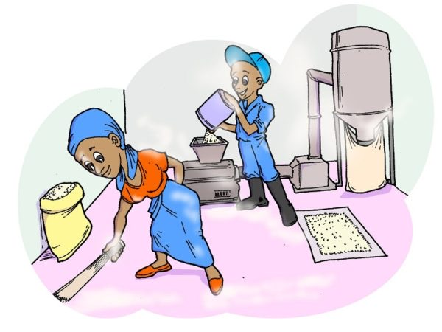
Introduction
Waste and chemical management objectives contributes directly to twofold programmes of action: (1) green industry and private sector development and (2) IWRM. The waste and chemical management through green industry seek to promote resource efficient industries for water and energy, greening the Special Economic Zone (SEZ) and provincial industrial parks, promoting green technologies and building carbon trading capacity. (Rwanda GGCRS, 2015). Resource efficient and clean production has been introduced to industry in Rwanda and needs to be scaled up to improve energy and water efficiency, thus reducing emissions and promoting resilience. Promotes sustainable mining practice water reuse technology Afforestation of degraded sites (IWRM), Off-farm employments created for females, private investors involved in environmental management.
Compared to men, women are particularly underrepresented in industrial sphere. The women and men roles influence the gender stereotypes and has resulted in male dominated industrial activities. However, the negative indirect impact and risk of inadequate waste management and climate risks associated to industry affect more females than men, worsening gender inequalities. Green industry development offers opportunities for gender inclusion in off-farm green employment and contribute to reduce pressure on natural resource, recycling wastes
Limited participation of women in green industry development
Female household heads are not sufficiently included in planned settlements thus don’t manage wastes and domestic rubbish.
Entry points for gender mainstreaming along in policy or planning cycle :
In line with green industry development in relation with GGCRS programme of action, the following entry points are proposed:
- Engagement of both women and men in design, plan and implementation of green industry development;
- Consider including women incubators for start up in SEZ and provincial industrial parks development; i.e: Developing incentives and credit enhancement and micro-finance programs specifically targeting women engaging in food processing project with clean energy efficient technologies.
- Establish a meaningful link between green small- and medium- enterprises (SMEs) with support organisations, incubators, centres of excellence, and financial institution for scale –up productions.
- Undertaking education, outreach, and awareness-raising activities focused on green industry development; agro-processing industries constructed with green technologies (energy efficiency, water resource efficiency and waste water treatment)
- Considering gender issues at every stage of the low carbon systems project cycle for example: i.e: Promote and support women cooperatives or companies engaged in collection of garbage left in the streets and along riverbanks to realize handcrafts; Cooperatives of women producing handcrafts from waste paper; Youth artists engaged in making artistic and decorative structures, furniture, monument from non recyclable waste. Organic packages (bags, cups) production made by women cooperatives, manufacture of construction material and furniture made in bamboo to reduce use of plastic items (house roofs: plafond, carpets, bamboo, etc)
- Conduct research on gender mainstreaming assessment of mining sector and integrated findings in projects and plans;
Mainstreaming gender in new innovative trends of green industry which are proposed by sustainia 100 should be explored for applicability in local context: i.e:

  - Innovative take back for collecting used apparels, footwear and textiles for reuse and recycling;
  - Bio-based product for pest management;
  - Carbon-negative plastic making;
  - Carpets that clean the air for better indoor climates;
  - Leasing jeans for a circular fashion industry;
  - Establishment of automated e-waste kiosks;
  - Soil block /bricks for affordable construction (rukarakara);

Sample Gender Sensitive Indicators

Nn1. | Sample gender sensitive indicators
1. | Number of off-farm SMEs created around protected areas and degraded areas by sex of owners.  Number of families touched by dissemination and who use beekeeping to get family income
2. | Number of green industry initiative implemented by women and vulnerable groups (handcraft, bio-products, clean recycling , artistic and furniture making, textile recycling or reuse etc)
3. | Number of private investors involved in environmental management and greening by sex
 | Number of Youth entrepreneurial initiative supported by sex. Number of created green jobs by sex and by type of job;
4. | Number of certified green industries with gender equality seal
5. | Book plots of 5-10ha within SEZs and develop them for specific sub-sectors (prioritising Agro-processing sectors for start) No. of SEZ and industrial parks holding gender equality seal (including space for entrepreneurship and processing)
6. | Training on sustainable mining standards (environment protection and occupational health and safety) by gender
7. | Job creation for women and men in sustainable mining
8. | No. of gender sensitive research or EIA conducted in mining sector

Module 5:

How to Translate Policies Into Concrete Projects? PRACTICAL SESSION
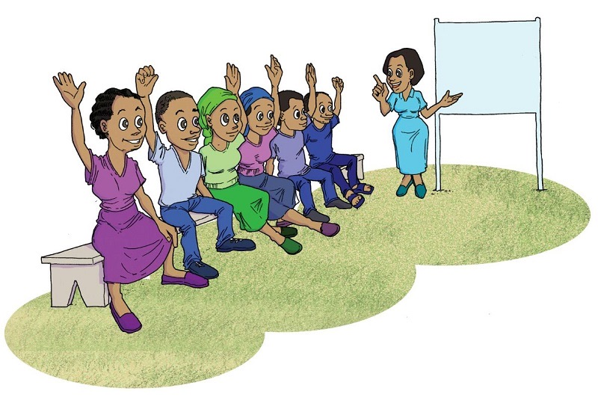
Learning outcomes:
After completing the module, participants will be able to:
Understand the objectives of this course
- Practicing the step by step guide for integrated project design for gender-environment and climate change
- Each participant will have the opportunity to apply all the acquired skills from previous modules (gender analysis, gender mainstreaming, and integration exercise.
Activities:
The course consists of:
- Guidelines (hands out)
- brief session for group exercise;
- - Practical group work and feedback presentations;
- case study sharing

Learn from the proposed strategies for improving women’s social economic status or other possible initiatives from your experience (Stakeholder engagement, Community based approaches, …) to practice a gender sensitive project designing.

Practical exercise

There is a green fund that is willing to provide grants to districts or CSOs that successfully contribute to address gender inequalities in environment and climate change for the above priority areas/projects.
Priority Programme for gender-environment and climate change grant are :

- Fish farming activity in Kivu lake
- Girinka programme
- Transport system development in a new secondary city to be Rwandan model green city
- Poverty reduction through business development project near Mukura forest (Rutsiro District)
- Waste management and recycling project in Kicukiro district
- Land consolidation for maize and vegetable intensification project in Yanze watershed including marshland
Every group 6-8 peoples nominates a leader, 1-minute taker, a presenter,
One group of four people is the donor panellist
Each group keep the previously selected project or programme from above list

TASK TO DO:
Each group try come up with a gender sensitive project/programme to win the grant. (Duration: 30 minutes). The facilitators distribute a simple proposal template and the step by step checklist for mainstreaming gender-ENR and CC in a project.

Key Notes:

- Each group has carried out gender analysis for one of the above projects See exercise under the Module (Module 3).: building a foundation for gender analysis.
- Manage your time and ask any question to the facilitator;
- When the groups are preparing the proposal, the donor is preparing interview question
- Present your proposal to the donor panellist which in turn ask question to each group to assess the gender &environmental impact of the applicants. Two winners’ groups are selected at the end of the exercise. Each group has 10 minutes for presenting its project.

Module 5: Gender Responsive Planning and Budgeting
Introduction

The sessions of this module introduce key concepts and gender mainstreaming tools for budgeting: Gender Responsive Budgeting (GRB), Gender Budget Statement (GBS), gender sensitive indicators, gender impact assessment (GIA), Environmental Impact Assessment (EIA). The module will also involve applied lecture with Rwanda case study on GRB. Intensive study and review of recommended literature continues throughout the course. A GBS writing-skills training in the end helps students to learn how to develop a GBS.
The course will address the following questions.
- What is a gender responsive budget and GBS?
- How is GBS elaborated?
- How to mainstream gender in EIA?

Learning outcomes:

After successful completion of this course students are expected to be able to:
-Understand Gender responsive budgeting and develop a quality GBS in for relevant sub-programmes in environment and climate change

Activities:

The course consists of:
- plenary lecture & practical hands out;
- Video Presentations; (GRB)
- Group work and presentations.

What is gender responsive planning/programming?
Gender-responsive programming and policies
Intentionally employing gender considerations to affect the design, implementation and results of programmes and policies. Gender-responsive programmes and policies reflect girls’ and women’s realities and needs, in components such as site selection, project staff, content, monitoring, etc. Gender-responsiveness means paying attention to the unique needs of females, valuing their perspectives, respecting their experiences, understanding developmental differences between girls and boys, women and men and ultimately empowering girls and women
Gender-sensitive programming and policies: Programmes and policies that are aware of and address gender differences.
A Gender-Responsive Approach: The particular needs, priorities, power structures, status and relationships between women and men are recognized and adequately addressed in the design, implementation and evaluation of activities. The approach seeks to ensure that women and men are given equal opportunities to participate in and benefit from an intervention, and promotes targeted measures to address inequalities and advance the empowerment of women. (Source: GEF Policy on Gender Equality 2017)
Gender-neutral programming and policies: Programming and policies that do not centre gender concerns or distinguish between genders in their design, interventions and monitoring. The mainstreaming should ensure both strategic and practical needs are addressed to ensure gender transformation.

Strategic gender needs
Requirements of women and men to improve their position or status. Addressing these needs allow people to have control over their lives beyond socially-defined restrictive roles. Strategic gender needs for women might include land rights, more decision-making power, equal pay and greater access to credit.
Practical gender needs
By comparison, are those needs required to overcome development shortcomings, that are gender-specific but do not challenge gender roles, such as access to healthcare, water availability and employment opportunities

Important note: Improving the socio-economic status of women and girls. How?
For any development actor, policy maker willing to improve the socio-economic status of women, many strategies are proposed:
- Develop and implement support programmes, projects, groups and individuals that aim at changing traditions, practices and institutions that discriminate against women. For example
- Mass public awareness programmes, legal literacy programmes etc) that aim at enhancing the socio-economic status of women and removing negative perceptions existing regarding women and the girl-child.
- Use different media strategies to do so (e.g. radio programmes, drama, education materials etc).
- Removal of negative perceptions of women is a basic human rights principle and has been proscribed by the Convention on the Elimination of all Forms of Discrimination against Women (CEDAW), a convention signed by the Government of Rwanda.
- Make women’s and men’s concerns and experiences an integral dimension of the design, implementation, monitoring and evaluation of policies and programmes in all political, economic and social spheres through gender mainstreaming.
- Bring about changes through respected change agents such as natural resources management committees Members, Religious Leaders, Village Leaders (Abunzi or conciliators, community health advisors, farmer promoters leads), teachers and others who are willing to address women’s rights and improve their status in society.
- Promote the recognition of the important role played by women in development processes (in environment and climate change). Economic empowerment is key to improving women’s status.
- District and local administration entities need to play an active role in promoting gender equality at the community level. In order to do so, local leaders and development actors should be aware of existing legal and customary rights, regulations and practices that affect men’s and women’s roles and responsibilities. In addition, they should have the knowledge, skills and financial means to address existing gender inequalities in their districts.
Why should public agencies consider GRP
- It helps to achieve effectiveness, efficiency, Equality, & empowerment.
- Assist to understand factors that affect dev’t activities & devise appropriate strategies to tackle them.
- Planning with a gender perspective enables planners to understand different roles in the society.
- Planning with a gender perspective helps to understand who has constraints in access & control of resources & who benefits.

Why Why should Sector Ministries and agencies consider GRB
- Improved efficiency by ensuring that those who need it most benefit from public expenditures
- Improves transparency & accountability of governments
- GRB analyses the government budget for its effects on women, men, girls and boys.
- GRB can ensure that government achieves international & regional commitments
- Help to categorize & distinguish policies using a gender perspective
- GRB can increase meaningful Participation of different actors in Planning & Budgeting policies

What is gender-responsive budgeting (GRB)?

Government planning, programming and budgeting that contributes to the advancement of gender equality and the fulfilment of women's rights. It entails identifying and reflecting needed interventions to address gender gaps in sector and local government policies, plans and budgets. GRB also aims to analyse the gender- differentiated impact of revenue-raising policies and the allocation of domestic resources and Official Development Assistance

Where does GRB originate from?
GRBIs were developed in recognition of the gender blindness of macro-economic policies and budgets.9 the first gender-responsive budget was introduced in Australia in 1984. Macro- economic policies and budgets do not recognise women’s unpaid labour and thus do not recognise or value the different contributions of women to the national economy as compared to men’s contributions. The national budget is the key document to any country’s development priorities. If a government’s national budget is not gender-sensitive, it is most likely missing women’s roles and contributions to national development efforts and thus not serving women’s needs and priorities. Women and men in all countries have different roles and responsibilities and often unequal access and control over resources and decision making; thus, budgets affect them differently.
Gender-Responsive Budget Initiatives
Gender-Responsive Budget Initiatives (GRBIs) analyse policies, taxation, revenues, expenditures, and deficits from a gender perspective. They are tools that make it possible to analyze budgets to assess whether government policies and programmes will have different and unequal impacts on women and men and girls and boys. GRBIs are not about separate budgets for women and men. They involve a gender-sensitive analysis of budget priorities. The exercise enables an analysis of budgets rather than the formulation of budgets. This analysis can then constitute the basis for formulation of budget amendments. Additionally, the analysis does not focus only on that portion of a budget seen as pertaining to gender issues or women. A full gender budget analysis examines all sectoral allocations of governments for their differential impacts on women, men, girls and boys. They can go further and look at the sub-groups of the gender-age groupings (Budlender, 2000:1366).
While a change in the government budget is the ultimate objective of most GRBIs, many other gains can be made along the way. In particular, GRBIs are ways of enhancing democracy by enabling public participation and transparency in finance and decision making and improving governance. GRBIs allow government departments, non-governmental organizations, and other stakeholders to improve accountability and targeting of services, ensure that ministries and districts respond to their constituencies’ needs and priorities, ensure that policies are being implemented with the relevant budgetary allocations and assist in implementing government commitments to international conventions (Khosla, 2003:5).

What is a gender budget statement?
Program: Name of a Program
Subprogram: Name of a sub-Program
Total allocated budget to sub-program:
Gender Situational Analysis | Output | Activity | Indicator | Allocated Budget

Practical session:
Hands out or working documents: 3years National strategy
At least one sector policy
Sample of budget sheet or sector annual action plan
National gender policy
Budget Call circular: the GBS annex guidelines;
1Sample GBS in ENR sector

Exercise 1: Gender Budget Statement Elaboration

In a group, elect a leader, share the following responsibilities:
- 1 minute’s taker, a presenter,
- All group members must participate, the leader tasks peoples: on sex disaggregated data searching, gender gap identification, selection of subprogram and conformity to guidelines.
- Manage your time and ask any question to the facilitator;

Task to do:
- Use the sample of budget sheet or plan of action to develop a GBS for at least 2 sub programs (related to the GGCRS PoA). E.g. IWRM

Discuss and share experience with the participant next to your personal life in relation with sexual division of labour and roles (at village life, your own home, work, religious activities, field work etc. Afterwards share your main findings in plenary

Gender Mainstreaming in useful tools for environment and climate change

.

Discussion point

Useful document/resources: EIA guidelines, PES guidelines

Gender Mainstreaming in useful tools for environment and climate change

How can gender be mainstreamed in Environmental Impact Assessment?
Can gender be mainstreamed in Payment for Environmental Services (PES)?
What would be the entry points for this mainstreaming?
- Gender equality benefits
- Environment benefits
After brainstorming, each group to present their findings. If possible, the facilitators provide additional information the facilitator shares key elements for measuring gender impact in EIA with concrete examples.
Finally, ask the participants what they have learned from the assignment.

Pre-training Assessment (PTA)

1.Mark with (x) the right answer according to your perception or experience:
As an employer, do you think you would hire female job seekers in the following job positions in your company?
 | Job type |  | Job type
( ) | Electrician | ( ) | Biogas maintenance technician
( ) | Mason | ( ) | Plumber
( ) | Wood machinist | ( ) | Chief architect
( ) | Climate change specialist | ( ) | Mining chief operator
( ) | Handy worker in mining | ( ) | Foreman
( ) | None of the listed jobs | ( ) | All the above listed jobs
2.Do you think the Vision statement below are gender sensitive? Yes ( ), No ( )
“Rwanda to be a nation that has a clean and healthy environment, resilient to climate variability and change that supports a high quality of life for its society.” (ENR policy) Yes ( ), No ( )
“Competitive industrial and advanced services sectors producing over $1.5 billion of exports by 2020, while increasing the number of off farm jobs.” (industrial policy) Yes ( ), No ( )
3.Do you think this Mission statement is gender sensitive? Yes ( ), No ( )
“Development of infrastructure, building construction, road development, provision of energy services and support to government departments.”
4.In which phase of policy cycle do you think gender concerns are mostly given less consideration by ENR sector? Tick one or more answers
( ) | Policy design
( ) | Baseline Data collection and stakeholder consultation
( ) | ENR and climate change related Regulation/EIA
( ) | Planning phase and budget
( ) | Procurement phase
( ) | Implementation phase
( ) | Compliancy checking phase
( ) | Monitoring and evaluation phase
( ) | Human resource processes/recruitment
Indicate “true” or “false” to the following statements
True (T) or False (F)
Gender = Sex
Gender = women and girls
Gender inclusion in environmental interventions can increase environment benefits and sustainability
Climate change impact (floods, droughts, crop failure) equally affect the population of a given sector without difference for women or men , girls or boys
The senior management in the Ministry are key players in gender mainstreaming accountability, because without political will related decision making, initiatives for gender budgeting and building internal expertise are limited
Gender mainstreaming accountability should start by myself and every professional staff by integration of gender in daily work. Gender cell and gender focal points are there to facilitate and give needed guidance
Gender sensitive procurement cannot bring any economic benefits, instead these are social consideration which should be the priority of the Ministry of Gender and Family Promotion than MoE
Building facilities such as proper lighting, private and separate sanitary facilities , support frames, child play area, public sitting area don’t significantly influence infrastructure users, people will use the building and roads with or without these
Non gender friendly machinery (i.e.: pump for irrigation that requires much physical efforts, costly equipment’s, high interest agriculture loans, can hinder environment benefits and also lead to increased vulnerability to droughts by farmers (crop failure).
The budget to address gender and environment and climate change issues should be earmarked by the Ministry of Gender equality and Family
-Thank you for your answers! –

TRAINING EVALUATION TEMPLATE
Please take a few minutes of your time and consider each of the following questions to help us evaluate this workshop and make it better for the next participants.
- Indicate your satisfaction with the following elements of the training on a scale from 1 to 5.
(1 – Not satisfied at all ..... 5 – Very satisfied)
Workshop content | 1 | 2 | 3 | 4 | 5
Working in small groups | 1 | 2 | 3 | 4 | 5
Presentations/plenary sessions | 1 | 2 | 3 | 4 | 5
The facilitator’s methods and skills | 1 | 2 | 3 | 4 | 5

- Did the workshop meet your expectations? If the workshop did not meet all or some of your expectations, please tell us which of your expectations were not met.
- Please list the things you particularly found useful. Please list the things you did not find useful or relevant. Please, explain why. How well did the workshop meet its main objective?
- How would you assess the level of your current knowledge and understanding in the following topics [ include the same issues as in pre-training assessment ] (5 – I understand the topic very well ..... 1 – I do not understand the topic at all)

Gender- environment and CC nexus____
Gender analysis and concepts in general ____
Gender mainstreaming, in a project/program cycle ____
Policy framework ____
Gender sensitive approaches in14 E & CC programmes of action ____
Development of Concrete Project on G-E&CC ____
Gender Budget Statement ____
Constructing gender indicators ____
Comprehensive Checklist for E&CC mainstreaming in sectors and DDS____

5)Is there anything else you would like to share with us? Mainstreaming challenge, new discovery or lesson learnt)

Thank you for your time!

References

WEDO, 2018. A pocket guide to gender equality under UNFCCC, edition 2. Found at: https://wedo.org/wp-content/uploads/2018/04/2018-Edition-of-Pocket-Guide-to-Gender_1.pdf
- Ergas, C & York, R. (2012). Women’s status and carbon dioxide emissions: A quantitative cross-national analysis. In Social Science Research. Volume 41, Issue 4, July.
- BRIDGE. Gender and Indicators Cutting Edge Pack. 2007. Available at: http://www.bridge.ids.ac.uk/reports_gend_CEP.html#Indicators
- Canadian International Development Agency (CIDA).The Guide to Gender Sensitive Indicators. Minister of Public Works and Government Services Canada, 1997

GGGA, UNFCCC. Case studies Gender responsive initiatives. (undated, available at:
- GWA.Resource Guide Mainstreaming Gender in Water Management available at: www.genderandwater.org
- IUCN, 2009. Training Manual on Gender and Climate Change
- Sustainia , 2014. A guide to 100 sustainable solutions Green industry trends; https://issuu.com/sustainia/docs/sustaini100_2014?e=4517615/8110227

Definitions source: WEDO, 2017.: https://wedo.org/wp-content/uploads/2018/04/2018-Edition-of-Pocket-Guide-to-Gender_1.pdf
The UN Framework Convention on Climate Change (UNFCCC) now has implementation informed by more than 50 decisions on gender equality made over recent years, including the Lima Work Programme on Gender (LWPG) and, in 2017, a first-ever Gender Action Plan (GAP) (Burns and Patouris, 2014; UNFCCC 2017). Among priority areas, the GAP includes a focus to strengthen monitoring and reporting of implementation of gender-related mandates under the Convention.
Gender assessment in project should explain: - Differences in women and men’s access to and use of forest resource, and land tenure rights; - Women and men’s forest knowledge, access to extension visits and education, and decision-making power within forest committees; - Classification of women and men activities engage on, their workloads and their households’ responsibilities; - Participation of women at different levels of forest product value chain
USAID, 2009, Promoting gender equitable opportunities in agricultural value chains: a handbook., Inc. (dTS) by Deborah Rubin (Cultural Practice LLC) and Cristina Manfre and Kara Nichols Barrett (dTS), p. 101-106.
Resource available at: https://issuu.com/sustainia/docs/sustaini100_2014?e=4517615/8110227

