Powering a Gender-Just Energy Transition

The Covid-19 pandemic has augmented pre-existing structural and experiential inequalities that women face in the energy sector. Reactionary responses to the pandemic have largely been gender blind worldwide; according to a review conducted by the UNDP and UN Women on global gender responses to Covid-19, out of the 3,099 social protection and labour market measures adopted across 221 countries, only 19.6% (606) measures address women's economic security or unpaid care. Energy systems must be decarbonised to limit the global temperature rise to 1.5° Celsius and achieve universal access to basic services. Energy transition interventions risk excluding women and other disadvantaged groups if they don’t consider existing sociocultural, socioeconomic, and institutional gaps. Decentralized renewable energy technologies can be a game changer to enhance access to reliable and affordable clean energy while clean cookstoves can provide access to safer cooking options, free up time of women and girls, improve indoor air quality and their health and reduce deforestation. A gender-just energy transition would result in multi-scalar gains. With an increasingly urgent demand for implementation and tangible actions, there is an increasing call to action for the importance of addressing long-standing inequalities and promoting women’s empowerment in the global energy sector.

Gender-Just Energy Transition Framework
A framework for a gender-just energy transition ensures that the rights of disadvantaged groups are met by addressing the root causes of gender inequality within and along a gender-transformative transition to a resilient and sustainable global energy sector. As consumers, suppliers and distributors of energy, disadvantaged groups face barriers across the energy value chain, which in-itself, also holds manifold implications for people of varying interests and needs. Such a framework would ensure that the projected and materialized benefits of the energy transition are distributed equitably and ultimately aim to strengthen the long-term participatory capacities of disadvantaged groups across the energy value chain. Awareness raising and introducing norms and regulatory measures promoting gender equality and enhancing transparency for equal representation of women and men across the sustainable energy value chain would also be required. No one is to be left behind in the shift from fossil fuel reliance, and a framework for a gender-just energy transition would bring together the interlinkages necessary in identifying entry points within and among the multiple dimensions of gender equality, the just transition, and decarbonisation.

Call to action:

- Women and men should get equal opportunities to participate in and support the clean energy economy, as entrepreneurs and employees, and be provided equal funding and investment for their businesses.

- The energy sector must mitigate gender-based vulnerabilities that have worsened with the pandemic, in health care, gender-based violence, and the digital economy.

- Women need better energy access and suitable appliances to support their roles in the care economy. Clean cooking is of special importance here.

- Women need to have a place at the table – or create their own tables – when strategies about energy transitions and post recovery strategies are planned and decided on

Two-Pronged Complementary Approach for a Gender-Just Energy Transition

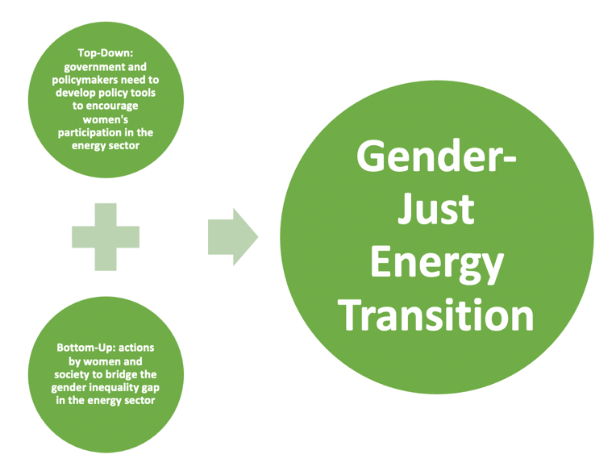
The GGKP Gender Expert Group
The GGKP Gender Expert Group was created in November 2021. It is a collaboration between leading green growth and green economy institutions influencing future interventions by identifying and responding to knowledge gaps for a gender-just green transition. The group provides research, capacity building and knowledge sharing to aid evidence-based policy development processes, specifically on integrating gender equality in green growth approaches.

To kick-start Phase 1 of its work programme, a mapping of current gender-transformative practices of GEG members and other institutions was carried out. It focused on what works, for whom, under what circumstances and how.

Following that, a knowledge product is being prepared to identify entry points for powering a gender-just transition to net zero. Guided by the principles of just transitions and energy justice, the working paper aims to analyze existing knowledge and strategies–research, policies, procedures, and programs that promote gender-transformative practices in the global energy sector. Best practice examples will highlight the role of various actors including local and central government, civil society, research institutions, donors, multilaterals, financing institution and the private sector.

UNDP. 2021. COVID-19 Global Gender Response Tracker: Global Factsheet Version 3 https://www.undp.org/sites/g/files/zskgke326/files/2021-11/undp-unwomen-covid19-global-regional-factsheet-2020-en-v4.pdf
Source: Adapted from recommendations of UNECE. 2022. Energy Transition and post-COVID-19 Socio-Economic Recovery: Role of Women and Impact on Them https://unece.org/sites/default/files/2022-01/Energy-Transition_Role-of-women-in-Post-COVID19.pdf

